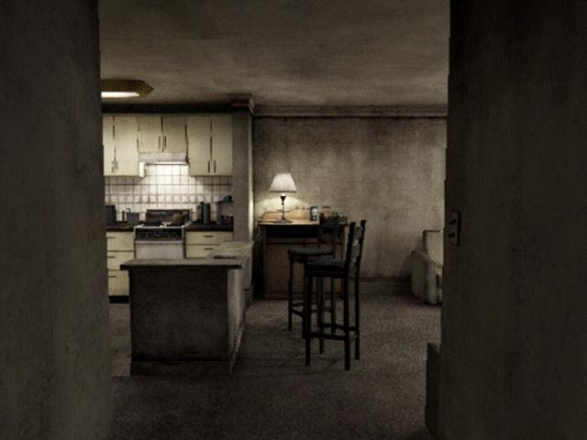

Level Design Document: The Elevator
  - Half Life 2: Episode 2 - Morgan Davis
  - Version 1.0

Designer: | Morgan Davis
Document Date: | September 3rd, 2012
Intended Level Delivery Date: | October 1st, 2012

Document Revisions Table
Version | Description | Requestor | Date
1.0 | Initial Document | Professor Ouellette | 9/5/2012

Table of Contents
Table of Contents 3
Table of Figures 5
Quick Summary 7
Hook(s) 7
Gameplay Highlights 7
Setting Summary 8
Mission Difficulty 8
Mission Metrics 8
Characters 8
Visual Themes 9
Key Theme References 9
Level Summary 10
Campaign 10
Context 10
Backstory 10
Aftermath 10
Objective(s) 10
Overview Map 11
Level Flow 12
Flow Summary 12
Level Progression Chart 14
Level Details 15
Gameplay Area Breakdown Map 15
Detailed Walkthrough 16
Area 1: Tutorial Section 16
Initial Loadout 16
Gameplay/Story 16
Text and Dialog 17
Visual References 17
Area 2: Generator Room 19
Initial Loadout 19
Gameplay/Story 19
Text and Dialog 19
Visual References 20
Area 3: Surreal Tunnel 22
Initial Loadout 22
Gameplay/Story 22
Text and Dialog 22
Visual References 22
Area 4: The Crawler Room 25
Initial Loadout 25
Gameplay/Story 25
Text and Dialog 25
Visual References 26
Area 5: Lights Out 28
Initial Loadout 28
Gameplay/Story 28
Text and Dialog 28
Visual References 29
Area 6: Lobby 32
Initial Loadout 32
Gameplay/Story 32
Text and Dialog 33
Visual References 33
Critical Asset List 36
References 37

Table of Figures

Figure 1: Initial Bedroom 8
Figure 2: Door to Apartment Rooms 8
Figure 3: Interior of an apartment 8
Figure 4: The Surreal Guts/Flesh Area 8
Figure 5: Overview Map (Thirteenth Floor) 10
Figure 6 - Lobby Overview Map 11
Figure 7 - Flow Progression Chart 13
Figure 8: Area Breakdown Map 14
Figure 9: Area 1 Detail Map with Keys 15
Figure 10 - Walking Zombie 16
Figure 11: Main Character, Gordon Freeman 16
Figure 12 - Stairwell 16
Figure 13: Exterior of the Building 16
Figure 14: Furniture Example 17
Figure 15: Elevator Example 17
Figure 16: Texture Example (Wallpaper) 17
Figure 17: Lighting Example 17
Figure 18: Area 2 Detail Map with Keys 18
Figure 19: Main Character, Gordon Freeman 19
Figure 20: Enemy Example 19
Figure 21: Zombie in Room Example 19
Figure 22: Bathtub Scene Example 19
Figure 24: Bathroom Example 20
Figure 23: Battery Setup 20
Figure 25: Texture of Walls 20
Figure 26: Generator Room 20
Figure 27: Area 3 Detail Map with Key 21
Figure 28: Main Character, Gordon Freeman 22
Figure 29: Terrain Example 22
Figure 30: Janitor's Closet Hole Example 22
Figure 31: Gate Example 23
Figure 32: Door to Janitor's Closet Example 23
Figure 33: Closet Example 23
Figure 34: Lighting (Dark) 23
Figure 35: Area 4 Detail Map with Keys 24
Figure 36: Main Character, Gordon Freeman 25
Figure 37: Torso Zombie 25
Figure 38: Destroyed in Places 25
Figure 39: Bedroom Layout Example 25
Figure 40: Room with windows (planked in game) 26
Figure 41: Kitchen Pieces 26
Figure 42: Wallpaper 26
Figure 43: Lighting (Ambient, but dark) 26
Figure 44: Area 5 Detail Map with Keys 27
Figure 45: Main Character, Gordon Freeman 28
Figure 46 - Walking Zombie 28
Figure 47 - Torso Zombie 28
Figure 48: Bathroom Example 29
Figure 49: Interior Layout Example 29
Figure 50: Floodlights 30
Figure 51: Light Fixture Example 30
Figure 52: Texture (Wallpaper) Example 30
Figure 53: Lighting Example (Bright, until battery taken) 30
Figure 54: Area 6 Detail Map with Keys 31
Figure 55: Main Character, Gordon Freeman 32
Figure 56: Walking Zombie Example 32
Figure 57: Terrain Example 33
Figure 60: Architecture Example 33
Figure 59: Model Example 33
Figure 58: Rubble Example 33
Figure 61: Texture Example 34
Figure 62: Lighting Example 34

Level Abstract

Quick Summary
"The Elevator" is a first person single player horror level set in the realm of Half Life 2. Gordon Freeman must escape a spooky and twisted apartment building. However, Gordon does not have any weapons, and must use the limited light he has to stop the evil creatures of the dark. The game features various keys that unlock the other apartment rooms, as well as notes left behind by the now dead tenants. Since the level takes place on the thirteenth floor, Gordon must use the elevator to get down. However, the generator room to power it is lacking two of its three necessary batteries. The player must find the batteries in the other rooms all while avoiding ruthless creatures.
Four Questions Entering the Design of this Level:

Why is this fun?
This level taps into the fear emotion. Players do not have the ability to fight back with a powerful weapon, and thus must fight back through defense, or simply run. This constant tension and illusion of danger always adds exhilaration to the game experience.

What makes this sequence interesting/memorable?
Even if the player knows something they must do, they still feel afraid and anxious. No one should forget taking out a battery that powers a significant light source, in turn awaking the nasty creatures lying in wait. It could also occur when zombies cut in half crawl all over the floor while the player jumps from box to box making sure to avoid their reach.

How will you communicate to the player what they need to do?
Players know the mechanics through the first minute or two of gameplay. They discover a locked door, the key to it, a note, and that the creatures freeze to light. From there, the players can figure out the rest of the level. Most of the tension comes from the anxiety the player knows they must go through, yet executing it anyway.

How can the player break it?
The player could lure some of the zombies back to previous lit sections. This could prove tricky and almost pointless to do, however.

Hook(s)
Light Mechanic: Zombies freeze when they encounter light. This new mechanic works well in this level because the player never obtains a weapon.

Gameplay Highlights
- Freezing enemies with light
- Escaping enemies that once had light on them
- Finding keys to gain access to other rooms
- Gaining high ground to specific zombie types
- Finding notes which contain subtle story background

Setting Summary
Theme | Thriller/Horror
Mood | Tense/Anxious
Setting | Apartment complex (interior only), Exterior outside view from window is dark/cloudy
Time of Day | 8pm
Season | Fall
Weather | Cloudy

Mission Difficulty
Position | Difficulty | Reasons
Beginning | 3 | The actual gameplay only presents two zombies at the beginning, but because Gordon does not have a weapon, they might catch some players.
Middle | 6 | The crawling zombies in one of the rooms never hit light, so the player must find creative ways to escape.
End | 8 | Another room has a ton of enemies unfreezing when the player takes a battery. This sequence could prove difficult to escape if the player does not think about it.
Scale: 1-10 (1 is Easiest and 10 is Hardest)

Mission Metrics
Play Time | 5-8 minutes
Critical Path | 15360 hammer editor units
Physical Area | 5120 x 5120 hammer editor units

Characters
Character | Description
Gordon Freeman | The protagonist of Half Life. He never talks or complains. He was an MIT student and worked on the Black Mesa Project.

Visual Themes
Theme | Description
Apartment | Apartment complex, eighteen floors tall. Long skinny hallways, doors everywhere, elevators, stairs, apartment rooms, janitor closets, generator room.
Suburban Exterior | The exterior is more apartment complexes, a block full of cars, tall buildings, and plenty of streetlights.

Key Theme References
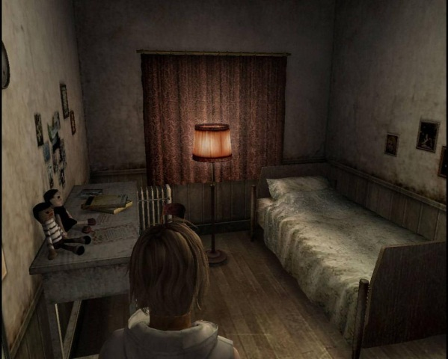
Figure 1: Initial Bedroom
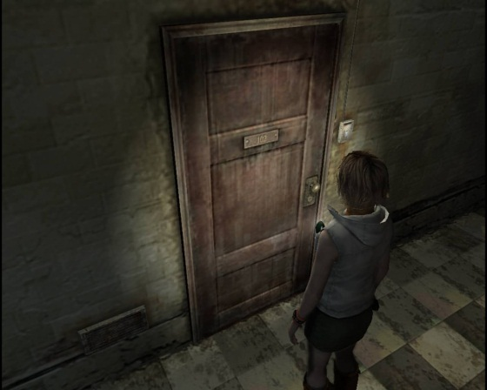

Figure 2: Door to Apartment Rooms

Figure 3: Interior of an apartment
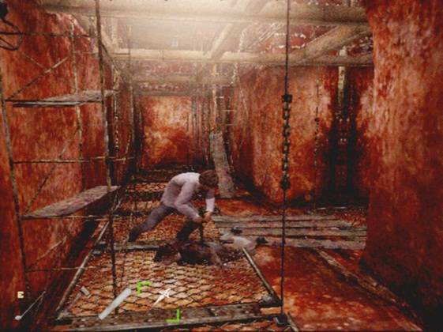

Figure 4: The Surreal Guts/Flesh Area

Level Summary

Campaign

Context
This is a level before Gordon Freeman finds physics interesting. Instead of a scientific career, Gordon pursues a religious one, hoping to discover a spiritual essence to human kind. Thus, he accepted a job working at a local church, and moved into this apartment complex.

Backstory
Prior to the Black Mesa event, and Gordon Freeman's school days, an incident known as the "Demonic Escape" happened in this apartment." Gordon moved into this apartment complex to begin his new job working at a church just down the road. One night, Gordon decided he would experiment with the spiritual world. In his room, he attempted to open a portal to something he did not understand. Nothing happened immediately, so Gordon went to bed. During the night, Gordon heard screaming, screeching metal, gunshots, and people whispering. He knew he had summoned something terrible into his apartment complex. Instead of going outside, he waited in his room nine days, eating all the food/water he had left. This level entails the moment Gordon decided to leave the apartment complex.

Aftermath
The character dies in the Elevator. Possibly the level could expand further if the designer comes back and changes the base engine to add a flashlight.

Objective(s)
- Escape the Apartment complex
  - Freeze zombies using the light
  - Find the batteries for the generator to turn on the elevator
  - Find the keys to unlock specific rooms
  - Read the notes (Bonus)

Overview Map
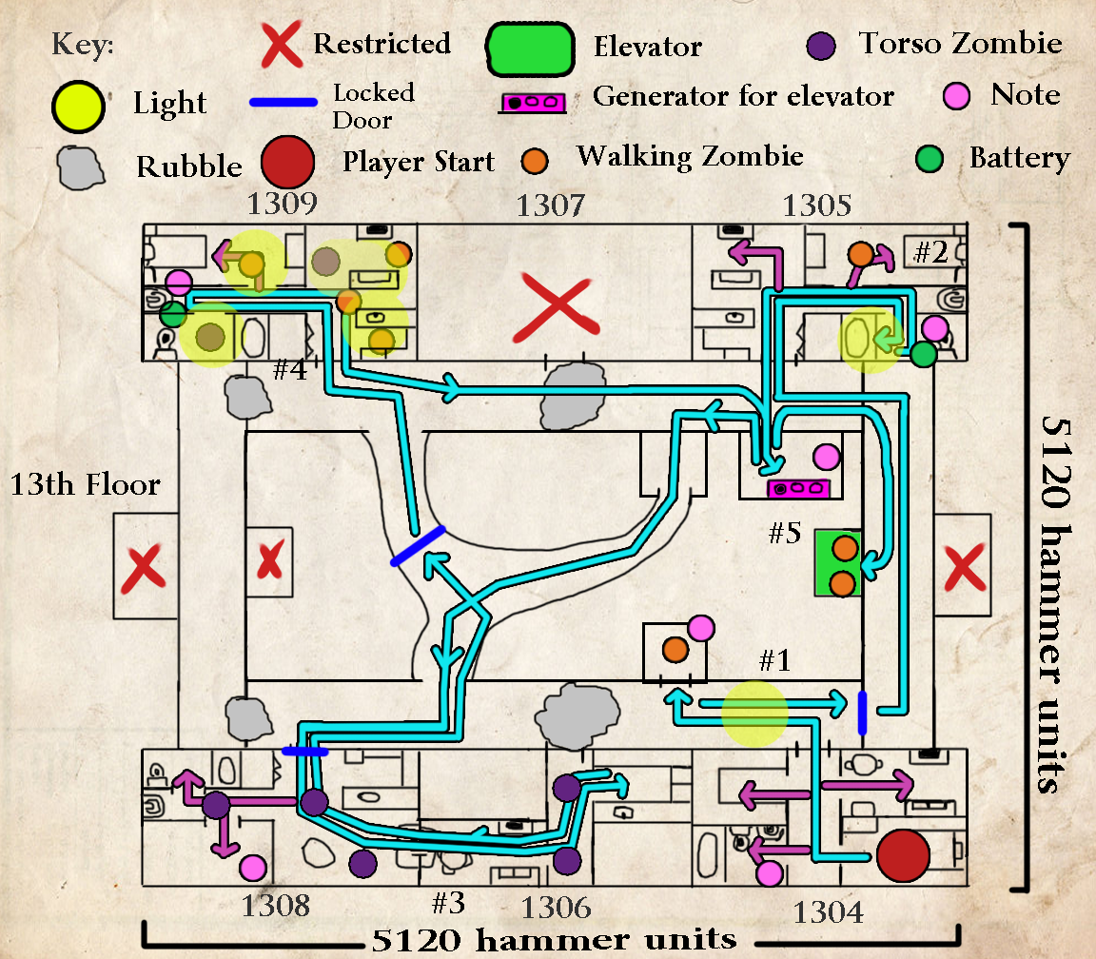
Figure 5: Overview Map (Thirteenth Floor)

Level Flow

Flow Summary
1. "The Tutorial" - players find their first note, learn that light freezes the enemies, and use their first key. They also see two zombies in an elevator (the door isn't open, but the player can see through it).
2. The First Apartment Room - Players find the first battery (technically 2 of 3) for the generator here. After picking it up, a zombie comes after the player from another room. The player can simply run or trap the zombie in the light in the bathroom. The player also finds a new key here.
3. On route to this second room, players go through a surreal middle part of the apartment. The walls look like a cave wall, and the music changes. In the apartment room, no lights can stop zombies. Instead the player must gain elevation to avoid the crawling torso zombies. The player retrieves a key here that opens the gate in the middle section.
4. After opening the gate, players make it into the third apartment room. Inside are multiple frozen zombies. A floodlight powered by a battery hold the zombies in place. The player must grab the final battery (this turns off the lights) and escape the zombies that awake.
5. The player places all three batteries in the generator room. Afterwards, the elevator from the first area powers on. The zombie inside freezes and the player must go down it with them in company.
6. However, the game ends with the Elevator stopping, and the lights go out. Unfortunately, the player doesn't make it.

Detailed Design

Level Details

Gameplay Area Breakdown Map
Figure 8: Area Breakdown Map

Detailed Walkthrough

Area 1: Tutorial Section

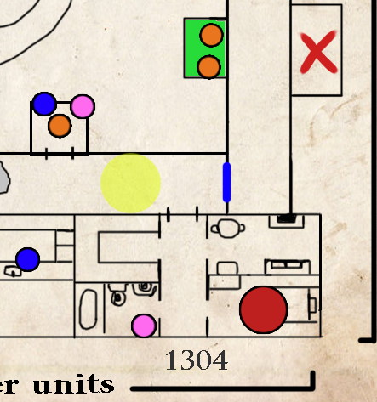
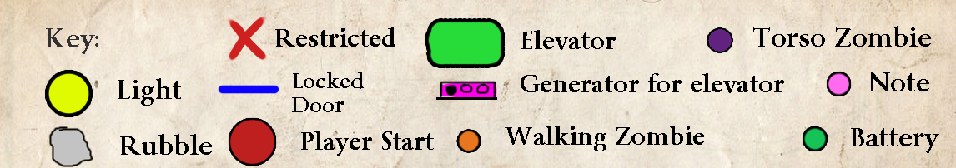
Figure 9: Area 1 Detail Map with Keys

Initial Loadout
- No Equipment/weapons/items

Gameplay/Story
- The player begins in their bedroom. Here the player finds a note that reads, "I must leave this place."
- When the player exits their apartment room, they encounter two doors. The one on the right is locked, meanwhile the "janitor's closet" door is not. When the player opens the janitor closet, a walking zombie comes out after them. With no place to go the player runs away, and the zombie hits the light in the hall, instantly freezing. Inside the janitor's closet is the key to the hallway door, and a note that reads, "I turn to stone, when you are gone."

Text and Dialog

Objective Text
- No Objective Text required (the notes do not count as objective text).

Dialog/Script
- No script/dialog

Visual References

Theme
Tall Apartment Complex Interior

Characters/Vehicles Introduced
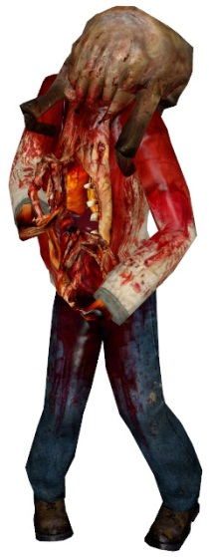
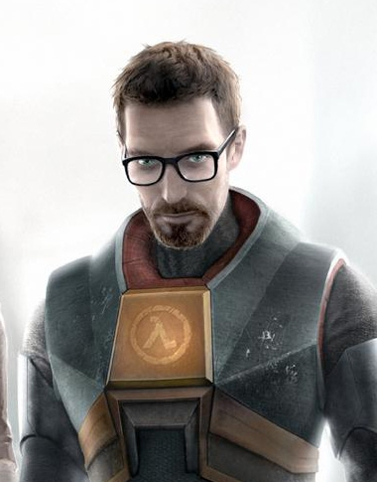
Figure 10 - Walking Zombie
Figure 11: Main Character, Gordon Freeman

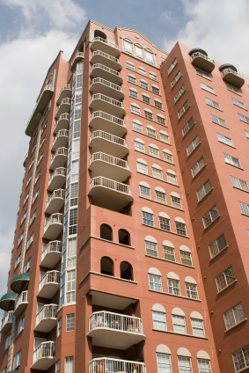
Environment References
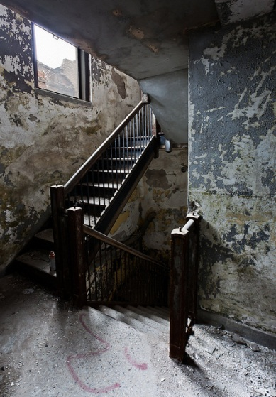
Figure 12 - Stairwell
Figure 13: Exterior of the Building

Figure 14: Furniture Example
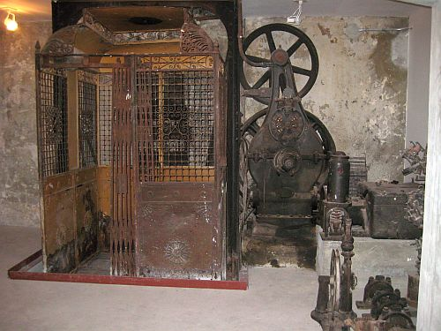

Figure 15: Elevator Example

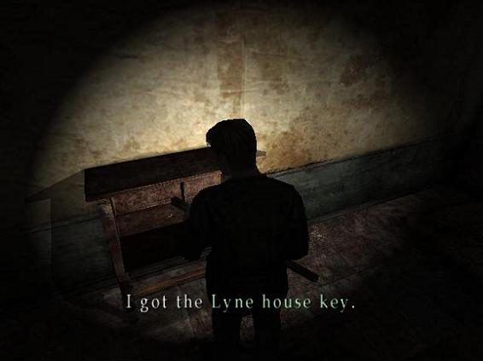
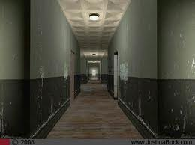

Figure 16: Texture Example (Wallpaper)
Figure 17: Lighting Example

Area 2: Generator Room

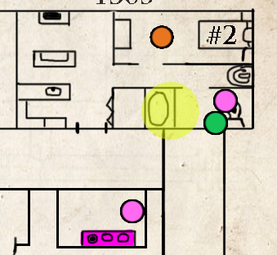
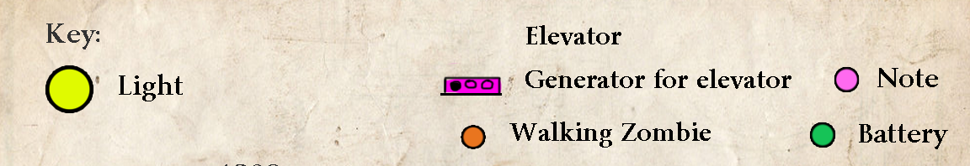
Figure 18: Area 2 Detail Map with Keys

Initial Loadout
- None

Gameplay/Story
- The player notices a generator room due to the light and noise emitting from it (the door is open). Inside the generator room is an electrical unit lacking two batteries.
- The room across from the Generator room houses the first battery. The battery connects into an electric wiring system that electrocuted someone in the bathtub. When the player takes this battery, a zombie pops out of the bedroom.
- In the bathroom, the player finds the key to room 1308, and a note that reads, "The echoes of the daylight. Of everything that is alive."

Text and Dialog
None

Objective Text
- None

Dialog/Script
- None

Visual References

Theme
Tall Apartment Complex Interior

Characters/Vehicles Introduced
Figure 19: Main Character, Gordon Freeman

Figure 20: Enemy Example

Environment References
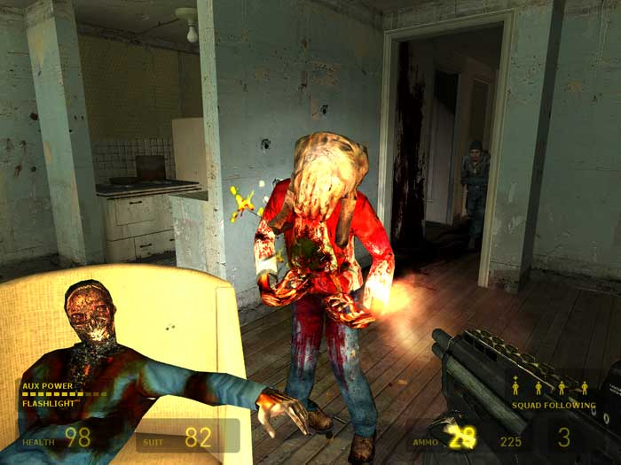
Figure 21: Zombie in Room Example
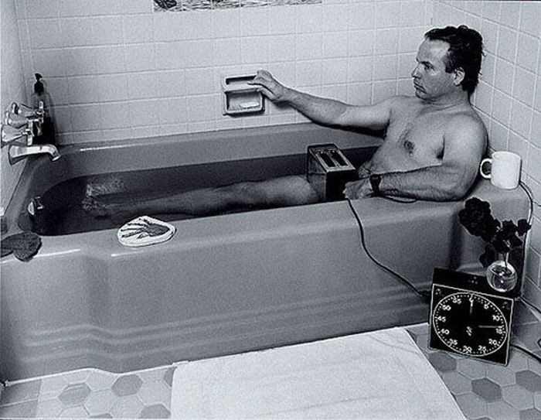

Figure 22: Bathtub Scene Example

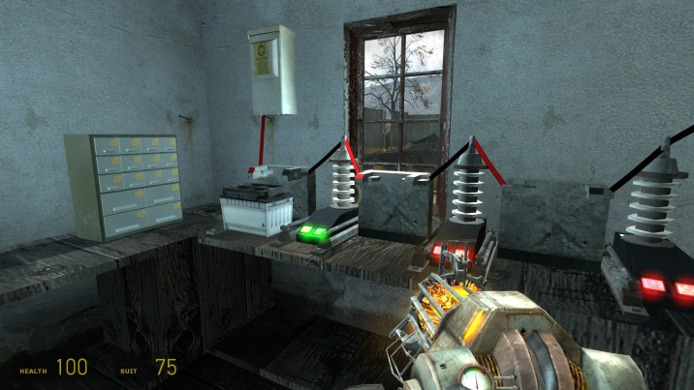
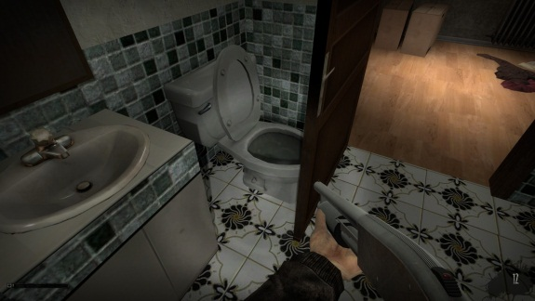

Figure 24: Bathroom Example
Figure 23: Battery Setup
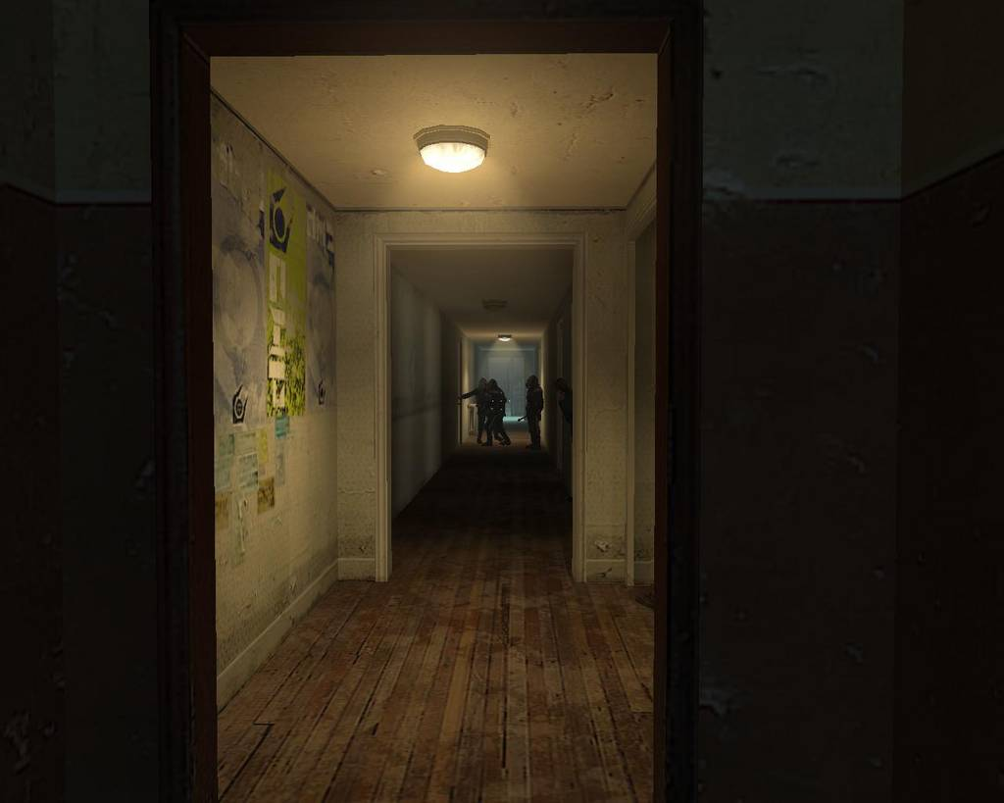
Figure 25: Texture of Walls
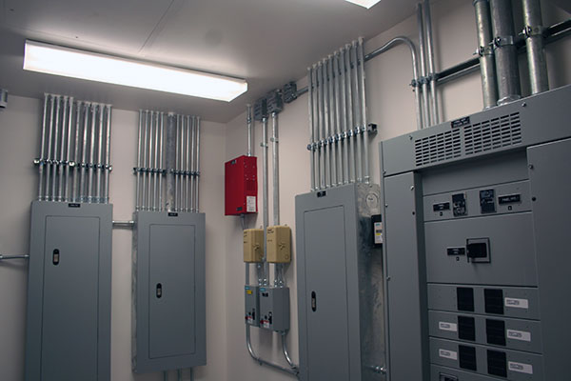

Figure 26: Generator Room

Area 3: Surreal Tunnel

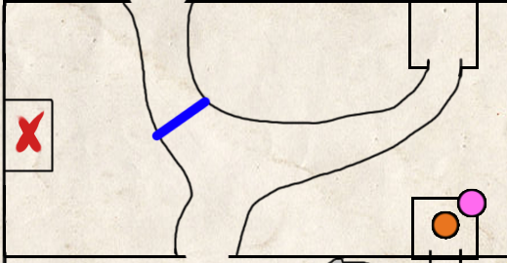
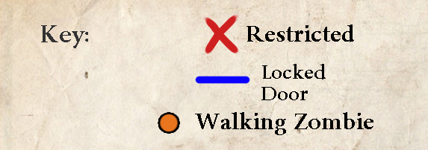
Figure 27: Area 3 Detail Map with Key

Initial Loadout
- None

Gameplay/Story
- Coming through another janitor's closet, this section adds a moment of surrealism. New music plays, adding tension to the moment. In addition, this area is dark and nasty feeling.
- A gate presents a blocking point to the player, and acts as foreshadowing to a key pickup later.

Text and Dialog

Objective Text
- None

Dialog/Script
- None

Visual References

Theme
Flesh walls, cave tunnels

Characters/Vehicles Introduced
Figure 28: Main Character, Gordon Freeman

Environment References
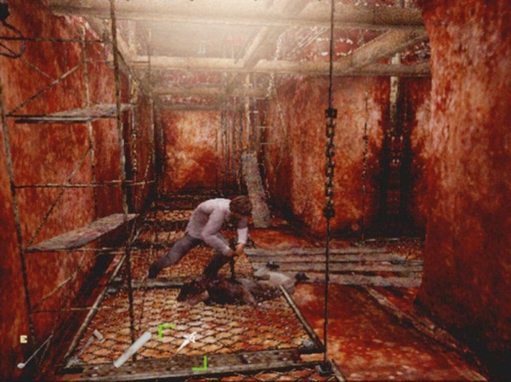
Figure 29: Terrain Example
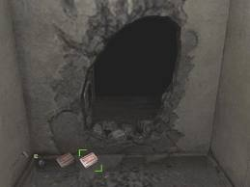

Figure 30: Janitor's Closet Hole Example
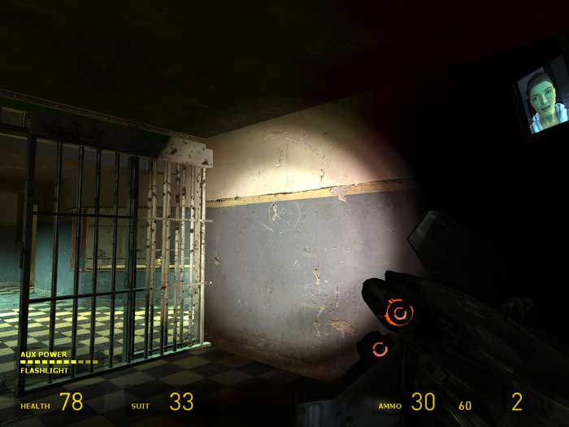
Figure 31: Gate Example

Figure 32: Door to Janitor's Closet Example
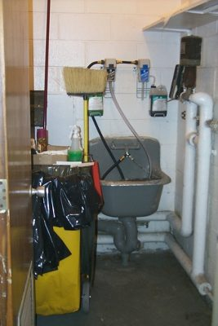
Figure 33: Closet Example

Figure 34: Lighting (Dark)

Area 4: The Crawler Room

c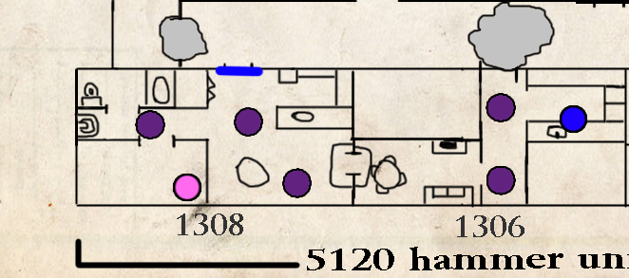
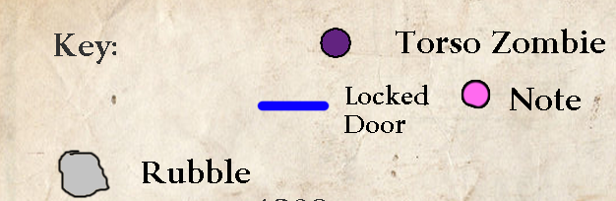
Figure 35: Area 4 Detail Map with Keys

Initial Loadout
- None

Gameplay/Story
- Using the key from the generator section, players enter Room 1308. In this room are several torso zombies. These zombies move quickly, but cannot climb or jump up. Therefore, the player must gain verticality to avoid them.
- The player moves through a broken part of the wall into the adjacent room (1306). Here are more zombies on the floor, so the player must try to stay on top of boxes/couches to avoid them. The player finds a key at the end of this section that opens the gate in the middle surreal section.
- If the player chooses to go after the note in the bedroom of 1308, it reads, "I sit here and I wait."

Text and Dialog

Objective Text
- None

Dialog/Script
- None

Visual References

Theme
Tall Apartment Complex Interior

Characters/Vehicles Introduced
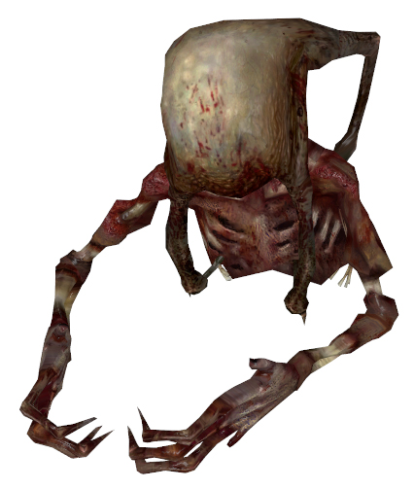
Figure 36: Main Character, Gordon Freeman

Figure 37: Torso Zombie

Environment References
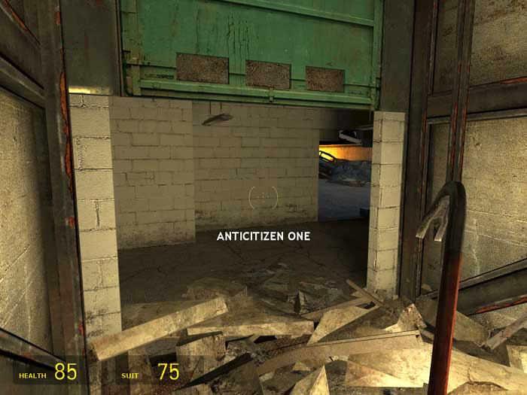
Figure 38: Destroyed in Places
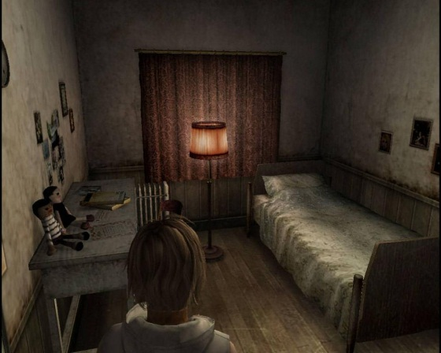

Figure 39: Bedroom Layout Example

Figure 40: Room with windows (planked in game)
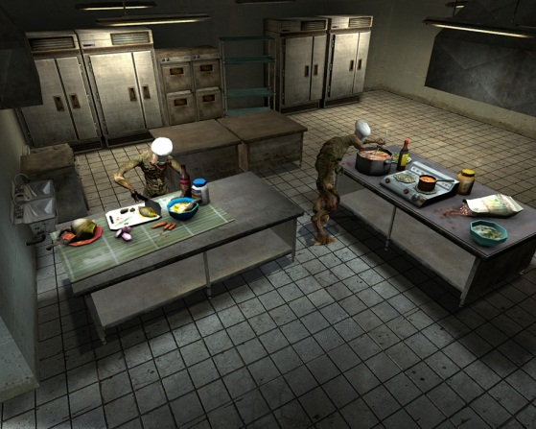
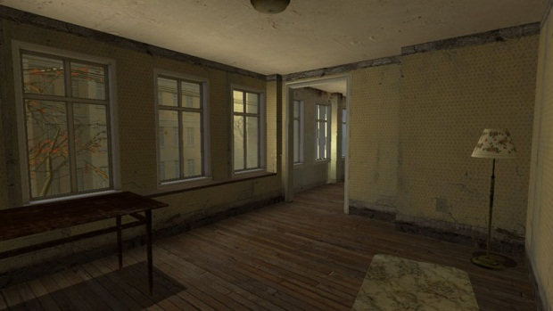

Figure 41: Kitchen Pieces

Figure 42: Wallpaper
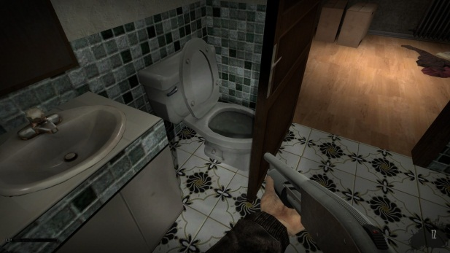

Figure 43: Lighting (Ambient, but dark)

Area 5: Lights Out

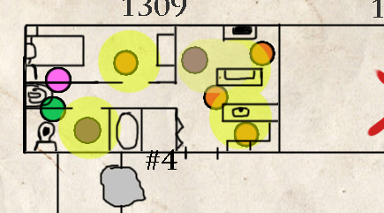
t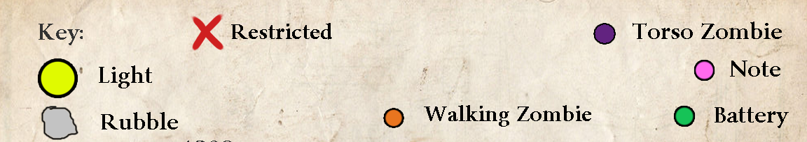
Figure 44: Area 5 Detail Map with Keys

Initial Loadout
- None

Gameplay/Story
- When first entering this area, the player notices a handful of zombies frozen by a couple headlights scattered in the apartment. The player must take the final battery and run out of this area, hoping to escape the claws of the unfrozen zombies. Both types of zombies exist in this room.
- Before grabbing the battery, players can read a note: "the lights don't shine no more."

Text and Dialog
None (except the note)

Objective Text
- None

Dialog/Script
- None

Visual References

Theme
Tall Apartment Complex Interior

Characters/Vehicles Introduced
Figure 45: Main Character, Gordon Freeman

Figure 46 - Walking Zombie

Figure 47 - Torso Zombie

Environment References

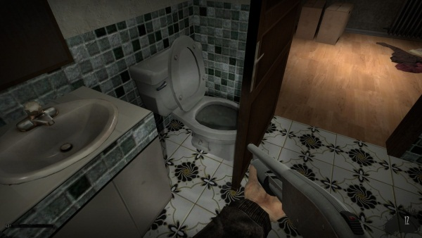
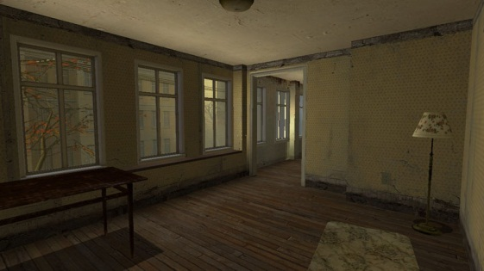

Figure 49: Interior Layout Example
Figure 48: Bathroom Example
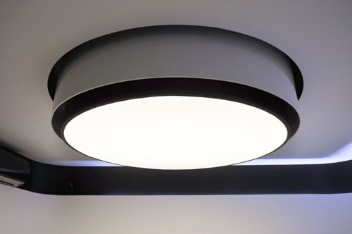
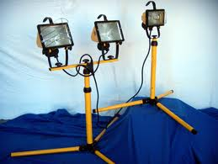

Figure 50: Floodlights
Figure 51: Light Fixture Example
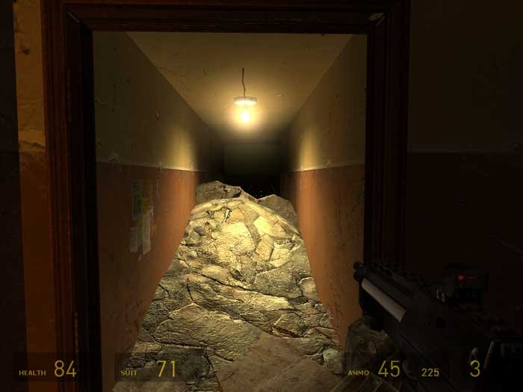

Figure 53: Lighting Example (Bright, until battery taken)
Figure 52: Texture (Wallpaper) Example

Critical Asset List
Asset Name | Type | Use | Exists? | Link/Pic
Info_player_start | Entity | For the player to spawn | Yes
Light_point | entity | For all of the lights | Yes
Npc_zombie | AI | Main enemy | Yes
Npc_fastzombietorso | AI | Second enemy | Yes
Blood Decal | Decal | Blood decoration on the walls | Yes
Note Mesh | SM | For the note pick up | No | N/A
Key Mesh | SM | To pick up and unlock doors | No | N/A
Prop_Door_Rotating | Entity | Doors | Yes
Elevator Mesh | SM | For the elevator | Yes
Elevator Door | SM | For the elevator | Yes
Logic_auto | entity | Sets up the level's scripting | Yes
Furniture | SM | For decorating the rooms | Yes
Apartment Wallpaper | Texture | For the BSP texturing | Yes
Battery | Mesh | For the battery/generator | Yes

References

Flesh Wall:
http://img210.imageshack.us/img210/2166/sh4c.jpg
Apartment Room:
http://www.homemademech.com/Uploads/Greview/7131108856173.jpg
Bedroom with lamp:
http://images1.wikia.nocookie.net/__cb20091126070241/silent/images/thumb/d/d6/Heather%27s_room.jpg/1000px-Heather%27s_room.jpg
Apartment 102 Door:
http://images4.wikia.nocookie.net/__cb57887/silent/images/b/ba/HeatherApartment.jpg
Gordon Freeman:
http://3.bp.blogspot.com/-ybZxfejFU4E/T6gtiRYNxuI/AAAAAAAAGps/ntq4Lx74JMU/s1600/Gordonfreeman.jpg
Walking Zombie:
http://images1.wikia.nocookie.net/__cb20090527180426/half-life/en/images/8/83/Zombie_HL2.jpg
Fast Zombie Torso:
http://images.wikia.com/half-life/en/images/1/1e/Fast_zombie_torso.jpg
Room from HL2:
http://www.ymag.it/wp-content/uploads/2010/04/015.jpg
Hallway with Combine:
http://img.gamefaqs.net/screens/a/a/d/gfs_53389_2_15.jpg
Another hallway from HL2:
http://t3.gstatic.com/images?q=tbn:ANd9GcQw7h7_WJFMOZxG8VVUOgxMUhrX1pJNop8WgkaTj7UmB_-VgaWyuA&t=1

Exterior of Apartment:
http://ohmyapt.apartmentratings.com/images/tall-apartment-building.jpg
Floodlights:
http://t1.gstatic.com/images?q=tbn:ANd9GcQ4j_2T0leG8XrhLq7Hkv0VtVPCuDBJHKkYi7wl8wkX5lsIyzDd2A&t=1
Old Elevator:
http://ahamedia.files.wordpress.com/2009/07/basement-of-hotel-pennsylvnia-5.jpg%3Fw%3D600
Janitor's Closet:
http://takemystockplease.com/wp-content/uploads/2011/02/janitors-closet.jpg
Electric Room (Generator Room):
http://www.vintageelectric.net/images/galleries/institutional/Electric-Equipment-Room.jpg
Bathtub Suicide:
http://thefortuno.com/wp-content/uploads/2010/05/The_Suicide_Series_12.jpg
Electric Circuit:
From Half Life 2 Gameplay
Hole in Wall:
http://t3.gstatic.com/images?q=tbn:ANd9GcRt_Ey6A3WEmf8LTvB3kl3Qy4d9MCMcLD_sQF_nnMl1u9lGs31szQ&t=1
Stairwell:
http://farm6.staticflickr.com/5338/7096439249_a983d5122d_z.jpg
Rubble:
http://www.visualwalkthroughs.com/halflife2/anticitizenone1/anticitizenone1.htm
Rubble 2:
http://www.visualwalkthroughs.com/halflife2/anticitizenone1/anticitizenone1.htm
Kitchen Models:
http://images1.wikia.nocookie.net/__cb20090111174953/half-life/en/images/2/28/Bm_kitchens.jpg
Apartment with Zombie:
http://www.visualwalkthroughs.com/halflife2/anticitizenone1/22.jpg
Metal Gate:
http://www.visualwalkthroughs.com/halflife2/entanglement/11.jpg
Light Fixture:
http://www.bodew.com/wp-content/uploads/2010/12/apartment-LED-lighting-fixtures.jpg

