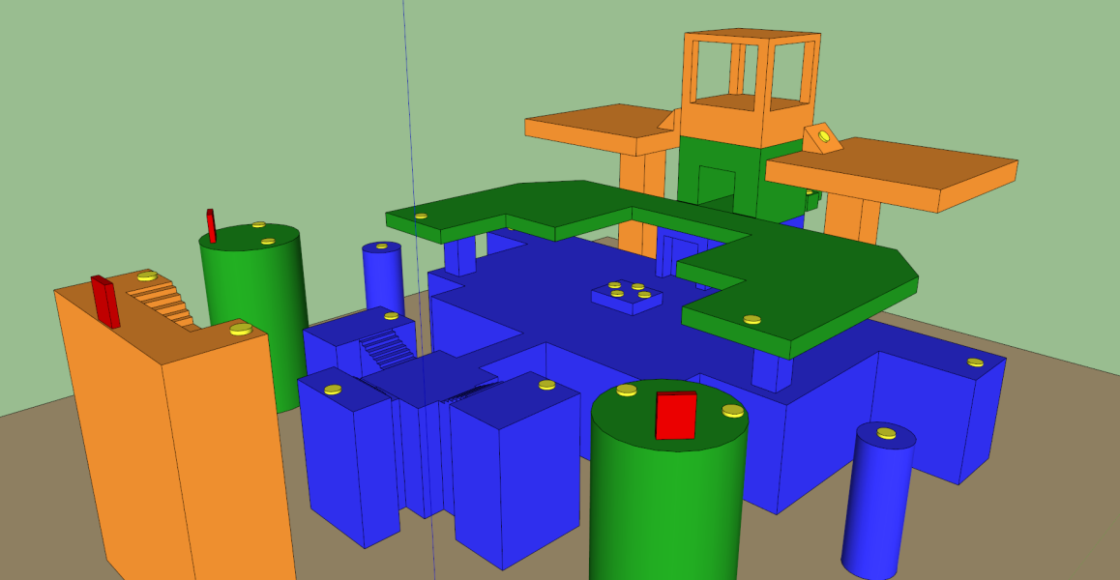

MP Level Design Document: Isolation
  - Unreal Tournament 3, DM-17: Isolation
  - Version 1.0

Designer: | Morgan Davis
Document Date: | 2/8/12
Intended Level Delivery Date: | 2/10/12
Document Revisions Table
Version | Description | Requestor | Date
1.0 | Initial Document | Professor McCoy | 2/7/12

Table of Contents
Table of Figures 6
Quick Summary 9
Gameplay Overview 10
General Game Flow 11
Major Elements 11
Objective Summary 12
Environmental Hazards 12
Technical Overview 13
Mission Location 13
Gametype(s) 13
Items/Powerups 13
Mission Difficulty 14
Mission Metrics 14
Level Details 15
Level Atmosphere/Mood 15
Major Characters/Vehicles 15
Story 15
Major Areas/Visual Themes 17
Area 1: Vulnerable Zone (First Floor) 18
Area 2: The Stretch (and all of Second Floor) 29
Area 3: Climax (The Third Floor) 41
Area 4: Sniper Roost (The Third Floor Island) 51
Level Objectives 58
Challenge Highlights 59
Water Cooler Moments 60
Actors 61
User Interface 63
Gameplay Details 64
Gameplay Mechanics 64
Level Overview Map and Key 65
Area Walkthroughs/Detailed Map Descriptions 66
Area 1: Vulnerable Zone 66
Gameplay 67
Dialog 67
Visual References 68
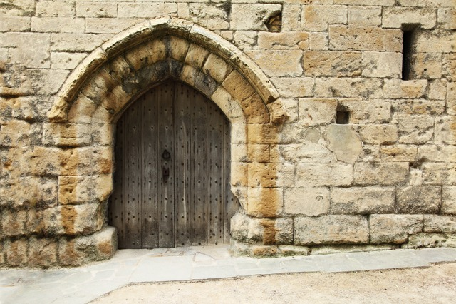 68
Area #2: The Stretch 69
Gameplay 70
Dialog 70
Visual References 70
Area #3: Climax 72
Gameplay 73
Dialog 73
Visual References 74
Area #4: Sniper Roost 75
Gameplay 76
Dialog 76
Visual References 77
References 78
Asset List 81

Table of Figures

Figure 1 - Flow Map of Isolation 9
Figure 2 - All Areas of Map 16
Figure 3 - Caucasus Mountains 17
Figure 4 - Cliffs before Water 18
Figure 5 - More Cliffs before water 18
Figure 6 - Olive Tree 19
Figure 7 - Vines 19
Figure 8 - Soil 20
Figure 9 - Stone walls 20
Figure 10 - NEC Columns 21
Figure 11 - Turkish Door 21
Figure 12 - Door Opened 22
Figure 13 - Square Tower 23
Figure 14 - Stone Steps 23
Figure 15 - Lighting Sample 1 24
Figure 16 - Lighting sample with dust 24
Figure 17 - Dust 25
Figure 18 - Cobblestone Texture 25
Figure 19 - Iron Guard characters 26
Figure 20 - Ronin characters 26
Figure 21 - Krall characters 27
Figure 22 - Liandri characters 27
Figure 23 - Caucasus Mountains 28
Figure 24 - Cliffs above water 29
Figure 25 - More Cliffs near water 30
Figure 26 - Olive Tree 30
Figure 27 - Soil 31
Figure 28 - Vines 31
Figure 29 - Stone walls 32
Figure 30 - NEC Columns 32
Figure 31 - Bridge 1 33
Figure 32 - Bridge 2 33
Figure 33 - Stone Tower 34
Figure 34 - Mosque Roof 35
Figure 35- Square Tower 36
Figure 36 - Lighting Sample 1 36
Figure 37 - Lighting Sample 2 37
Figure 38 - Dust 37
Figure 39 Cobblestone texture 38
Figure 40 Iron Guard 38
Figure 41 Ronin 39
Figure 42 Krall 39
Figure 43 Liandri 40
Figure 44 - Caucasus Mountains 41
Figure 45 - Cliffs near Water 41
Figure 46 - More Cliffs Near water 42
Figure 47 - Vines 43
Figure 48 - Stone Walls 44
Figure 49 - NEC Columns 44
Figure 50 - Mosque Roof 45
Figure 51 - Square Tower 46
Figure 52 - Lighting Sample 46
Figure 53 - Lighting sample 2 47
Figure 54 - Cobblestone texture 47
Figure 55 - Iron Guard 48
Figure 56 - Ronin 48
Figure 57 - Krall 49
Figure 58 - Liandri 49
Figure 59 - Caucasus Mountains 50
Figure 60 - Cliffs near water 51
Figure 61 - More Cliffs Near water 51
Figure 62 - Vines 52
Figure 63 - Stone Walls 52
Figure 64 - Stone steps 53
Figure 65 - NEC Columns 53
Figure 66 - Lighting Sample 54
Figure 67 - Cobblestone texture 54
Figure 68 - Dust 55
Figure 69 - Iron Guard 55
Figure 70 - Ronin 56
Figure 71 - Krall 56
Figure 72 - Liandri 57
Figure 73 - Player chooses Ronin 60
Figure 74 - Krall Enemy 60
Figure 75 - Iron Guard Enemy 61
Figure 76 - Liandri Enemy 62
Figure 77 - Level Overview 64
Figure 78 - Legend 65
Figure 79 - Area 1: Vulnerable Zone 65
Figure 80 - Key to Area 1 66
Figure 81 - Door to Keg O' Health 67
Figure 82 - Location of Door in Relation to Area 1 67
Figure 83 - Area 2: The Stretch 68
Figure 84 - Key for Area 2 68
Figure 85 - Tower for Jumping 69
Figure 86 - Placement of Tower 70
Figure 87 - Hidden Area 71
Figure 88 - Area 3: Climax 71
Figure 89 - Key for Area 3 72
Figure 90 - Mosque like Roof for Tower 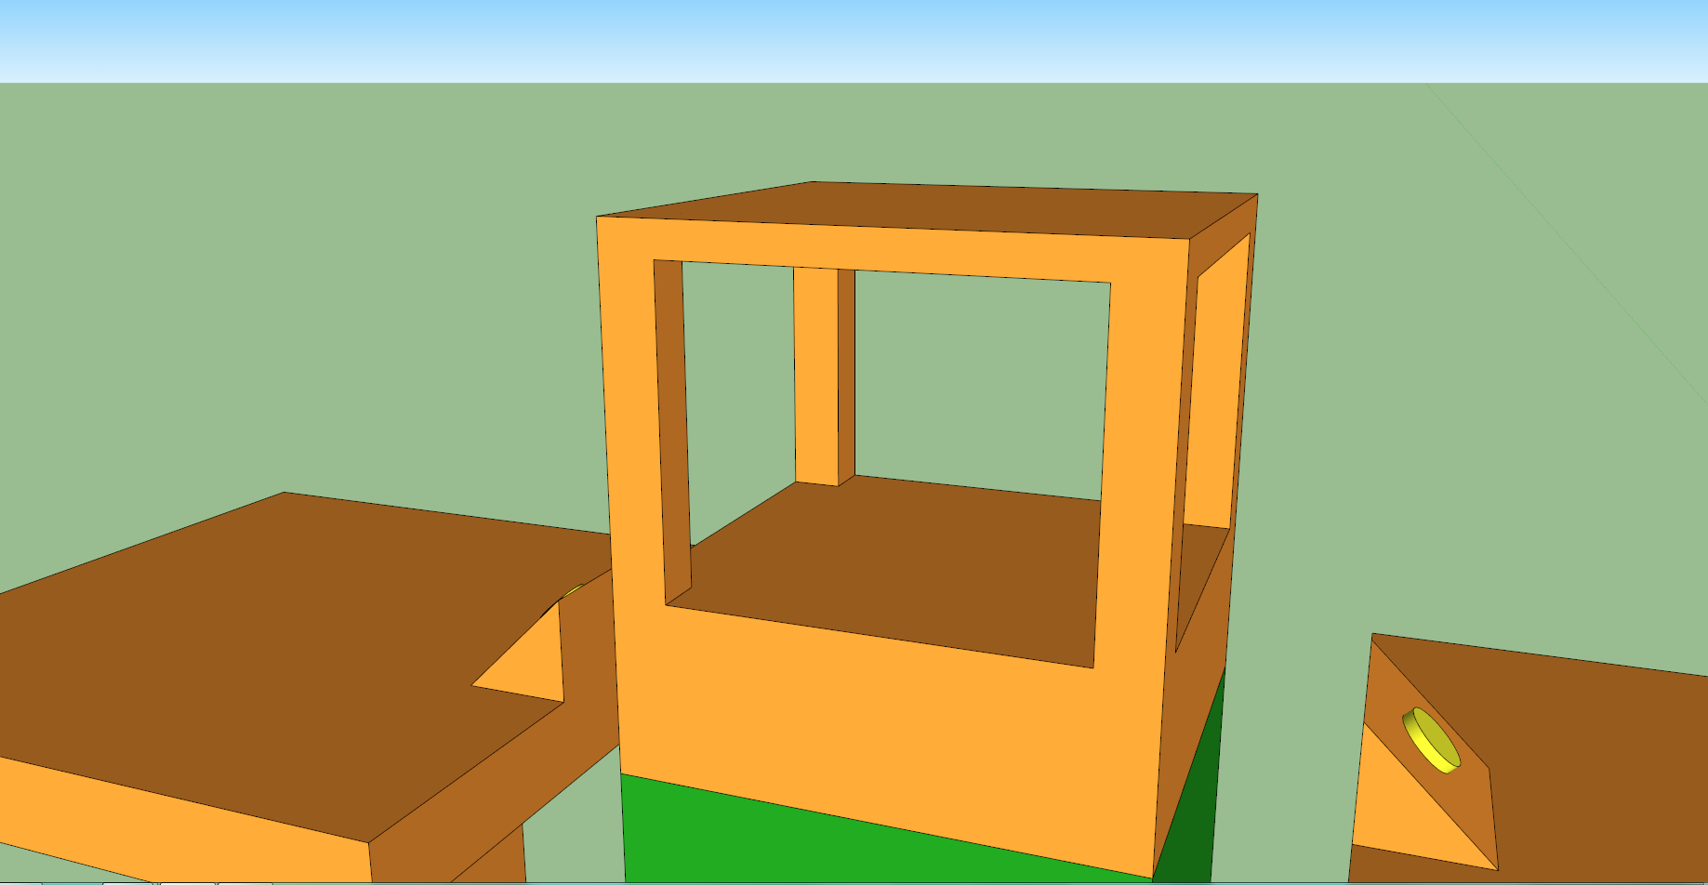 73
Figure 91 - Placement of Mosque Roof 73
Figure 92 - Area 4: Sniper Roost 74
Figure 93 - Key for Area 4 75
Figure 94 - View of Map (How it feels) 76
Figure 95 - View from Sniper Roost 76

Quick Summary
Isolation is a quick and fast-paced jumping frenzy around an ancient Turkish temple surrounded by legendary mountains.
This multiplayer Deathmatch level for Unreal Tournament 3 expands upon the original DM-17 map for Quake by adding better graphics and better gameplay flow. This level takes place outdoors within the roaring Caucasus Mountains near the Black Sea. Even after the area's conversion to an Unreal Tournament arena, this area retains its beautiful structure. This level ideally supports 16 players, but can manage as little as 8 players.

Gameplay Overview

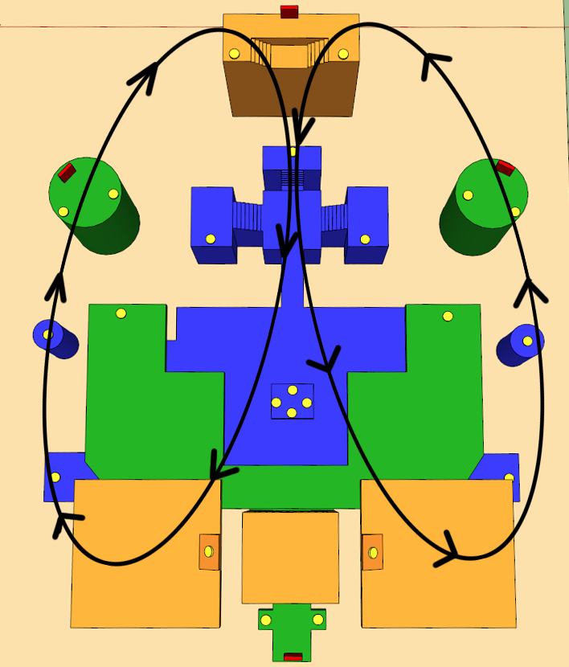
Figure 1 - Flow Map of Isolation

General Game Flow
With three floors to jump/teleport to and from, this map offers a massive amount of player path choices. Lone towers contain two jump pads and a teleporter, which translates to three choices the player can make at them. Of course, jumping down from any higher floor results in a change, and this level allows that action freely. Camping in this level proves extremely difficult since each area in the map is reachable quickly and rapidly. Exiting and entering any given area is easy with the options given in this map.
Game flow emphasizes moving quickly between areas both horizontally and vertically and using cross paths to attack enemies. When players use jump pads it makes sense and does not leave the player merely "hoping" the jump pad goes in the direction they want. This results in a quick learning curve of the area and does not detract from combat. The teleporters also aid in maneuvering to a dominating sniper or a power-up. As shown below, the game flows in circular motion. Constantly using this cycle proves to give the player height advantage, fresh weapons and ammo, as well as effectiveness in kill counts. The sniping in this level requires a quick eye-hand coordination rather than patience. A true skilled player can effectively snipe and keep others away when they arrive in vengeance.

Major Elements
- Players confront each other directly when heading towards the nearest weapon or health pickup.
- Players utilize teleporters to connect to distant parts of the map across the middle and upper platforms, as well as gaining advantage in the center of the map.
- Players avoid the edges of platforms that lead to instant death by falling.
- Players use jump pads to escape or assault from lower platforms to higher platforms.
- Players use various tiers of floors to give chase or evade opponents. (Hook)
- Players collide on the UDamage powerup located in a high-risk, centralized location.
- Players reach the Thigh pads powerup on the Sniper Roost's lower deck.
- Player use jump pads on the upper platform to crisscross and grab the Vest powerup.
- Players use a teleporter behind the main tower, which places them inside a room containing a Keg O’ Health. This pause from combat gives the player a quick breather before entering the battlefield again. Note: the doors exiting this room are one-way only and are not accessible from outside, which means players appear right in the midst of combat packed with lots of health. (WOW moment).
- Players vault outwards to the Sniper Roost, located in a vulnerable spot, for long-range combat.
- Players jump over to ancient towers to cross paths with the Sniper Roost, the high-risk central area, or back to the third floor in the back. (WOW moment)
- Major visual elements: The map emphasizes an old, dusty architecture that the players only stir up more. Turkish buildings, olive trees, cobblestone, and dirt pull out the remaining pieces of the map. Mountains and water create an ambient backdrop to finalize the beauty of the map.

Objective Summary
- Win: Default 20 kills
- Lose: Do not attain 20 kills. After the match is over, players analyze their final score compared to others.

This map is an objective-based Gametype that emphasizes running quickly and making split-second decisions while grabbing various gun types to defeat the opposing players. Instead of perfecting one gun's abilities, this map encourages the player to become great with all of the guns.
Not only does this map encourage gun use, it also does not hold the player's hand when it comes to evasion. Avoiding the heavy fire of an opposing player is one thing; add instant-death cliffs to the equation and the game is on! No other map in the game allows for the training this level provides.
Lastly and obviously, the player attempts to stay alive.

Environmental Hazards
Players die instantly from falling off any of the level's platforms into the cliffs/lake below.

Technical Overview

Mission Location
- Setting:
  - Time Period: This level occurs in the ruins of a Turkish temple, where legendary warriors trained before the Emperor of the Ottoman Empire.
  - Location: Inside the Caucasus Mountains in the country of Georgia.
  - Environment: Stone temple on top of rocky cliffs that are sitting in the valley of the great Caucasus Mountain Range.
  - Gameplay Setting: Deathmatch
- Time of Day: Around 4 pm (Earth time)
- Season: Fall
- Weather: Cloudy with a dusty wind hailing through.

Gametype(s)
- Deathmatch
  - Min Players: 8
  - Ideal Players: 16
  - Max Players: 16
- Team Deathmatch
  - Min Players: 8
  - Max Players 16

Items/Powerups
- Weapons Available
  - Sniper Rifle x 1
  - Link Guns x 2
  - Rocket Launcher x 2
  - Flak Cannon: 2 (1 at each base)
    - Note: To better resemble the original DM-17 map, which contained two shotguns, the Flak Cannons now exist.
  - Default Enforcer

- Powerups
  - Health: A total of 250 health distributed between different pickups (excluding Keg)
  - Armor: One vest and one thigh pad
  - Ammo: two (2) ammo packs for each weapon plus two packs for the Enforcer
  - Keg O' Health
  - UDamage x 1

Mission Difficulty
Scale: 1-10 (1 is Easiest and 10 is Hardest)
- Environmental Difficulty: This difficulty is measured by how easy/difficult the map is to navigate, and if there are any environmental hazards. The map has a difficulty of ten (10), since the cliffs are tight and disastrous. Players cannot focus on the environment and combat as easily when instant-death awaits both aspects of the game.
- Multiplayer Difficulty: Measured by the quantity of players between groups. The map requires a ton of practice, knowledge, and quick eye-hand coordination to beat; therefore, it is a ten (10) on the difficulty scale.

Mission Metrics
- Play Time: 20 minutes, server specified
- Length: 6144 Unreal Units, Width: 3072 Unreal Units, Height: 5120 Unreal Units
- Visual Themes: 3
  - A mountainous range surrounding the map
  - Stone architecture
  - Turkish trim and designs

Level Details

Level Atmosphere/Mood
The main theme of this level is dusty, old, and ancient. In order to achieve this, the level contains:
- Rocky mountainous terrain hiding the legendary location
- Turkish buildings that once belonged to the Ottoman Empire
- Stone towers built to last
- Wind blowing dust and dirt all over the level to create a mask of earth to the once perfect constructions
The beautiful environment inspires awe within the player and functions as an emotional boost to the stressful fight. As the battle progresses, the dust and dirt reminds the player that they too are part of the Earth and return as dirt/dust when killed. The particles from the slain warriors live inside of this dust, and the addition of an Unreal Tournament, the dust increases in number.

Major Characters/Vehicles
- The map uses the standard multiplayer characters from Unreal Tournament III, with no vehicles.

Story
During the Ottoman Empire, mighty warriors trained in the temple. Isolated from the world, this location allows a clear mind to focus on the tedious and challenging terrain that makes up the area. Warriors jumped to and from the towers as a way to practice lower body strength and agility. The tower functioned as a climbing wall for the warriors to build endurance and upper body strength.
When the Ottoman Empire faced war, it used the warriors as a special force in the battlefield. The warriors quickly jumped to and from the battle, taking out large numbers of foes. The training from isolation provided an unbeatable force.
Unreal Tournament then moved in many years after the Ottoman Empire died. The Turkish ruins in the Caucasus Mountains still possess the power of the legendary warriors who once trained there. With this in mind, warriors now fight and kill each other with this elite training ground dubbed Isolation.

- Intro
  - This map has no introduction. Players jump right in to one of the sixteen spawn points and begin fighting.
- In-Game
  - This map has no in-game story. The objective requires killing and surviving. However, players can see the architecture and form their own story from it.
- Extro
  - The level ends when a player makes a 20th kill. The map freezes and each player views their character in third person. Then after a few seconds, the match ends and the game returns to the menu.
- “60 seconds of gameplay”
  - An amazing fight is about to begin. Players eagerly wait as the countdown of the level ignites…3…2…1…Begin! Players scramble for the first weapon they see. Shooting with twitchy fingers, players attack one another using the Flak Cannon. Both take significant damage from each other, but another player from above finishes them off with his rockets. The players return to the battlefield, ready to try out a new strategy/weapon and gain back the revenge they rightfully desire.

Major Areas/Visual Themes
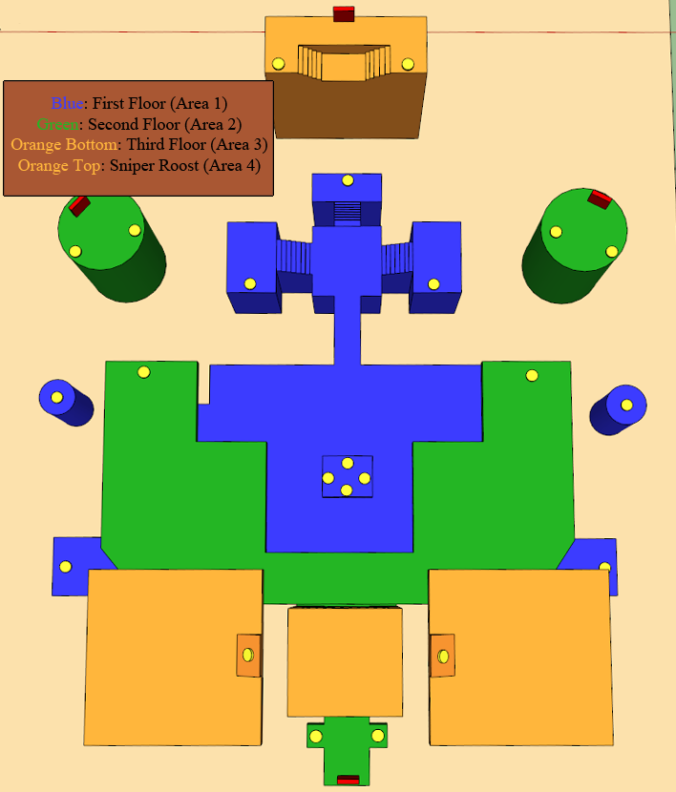
Figure 2 - All Areas of Map

Area 1: Vulnerable Zone (First Floor)

The Vulnerable Zone is the base of the level. It has stone blocks that sit atop mountainous terrain. Trees sitting in soil also pop up through the stone blocks (the blocks cut out) to give the area some life and beauty. Below the stone blocks are rocky chunks of the mountain. Further below the rocks sits the valley that is full of water. Columns from the NEC Static Mesh package connect this area to the one above it. At the base of the main tower (Areas 1,2,3 all share this tower) is a room. This room's doors have pointed arches and open up when the player teleports into the room (location of the Keg O' Health). The margins of the Vulnerable Zone contain tiny towers that allow jumping from the taller towers (Area 2) towards the first floor. Then players can use another jump pad to go directly to the third floor. The lighting is dim and dusty and makes the player feel worn down and old.

Visual References

Terrain/Vegetation
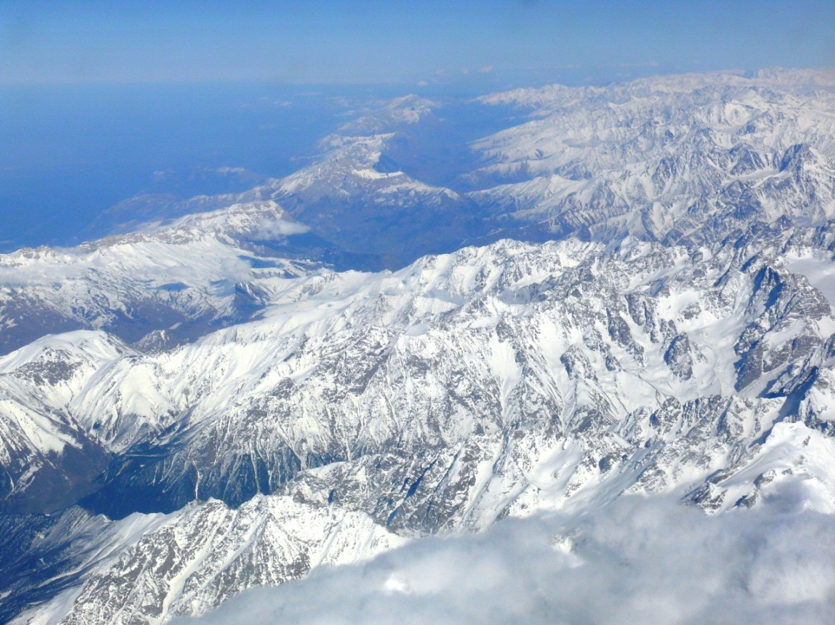
Figure 3 - Caucasus Mountains
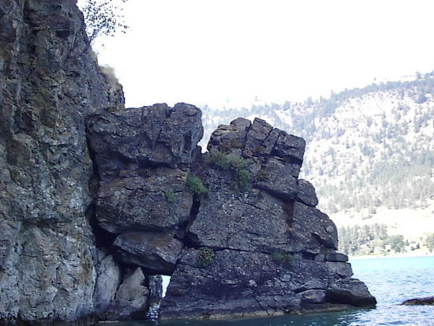
Figure 4 - Cliffs before Water
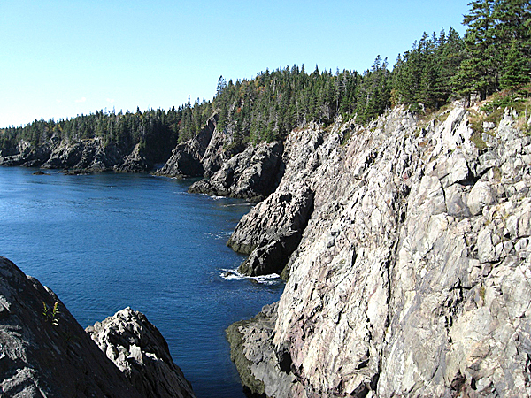
Figure 5 - More Cliffs before water
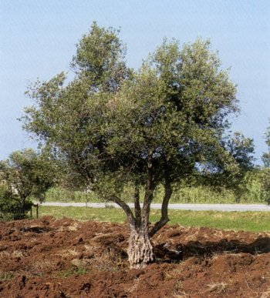
Figure 6 - Olive Tree
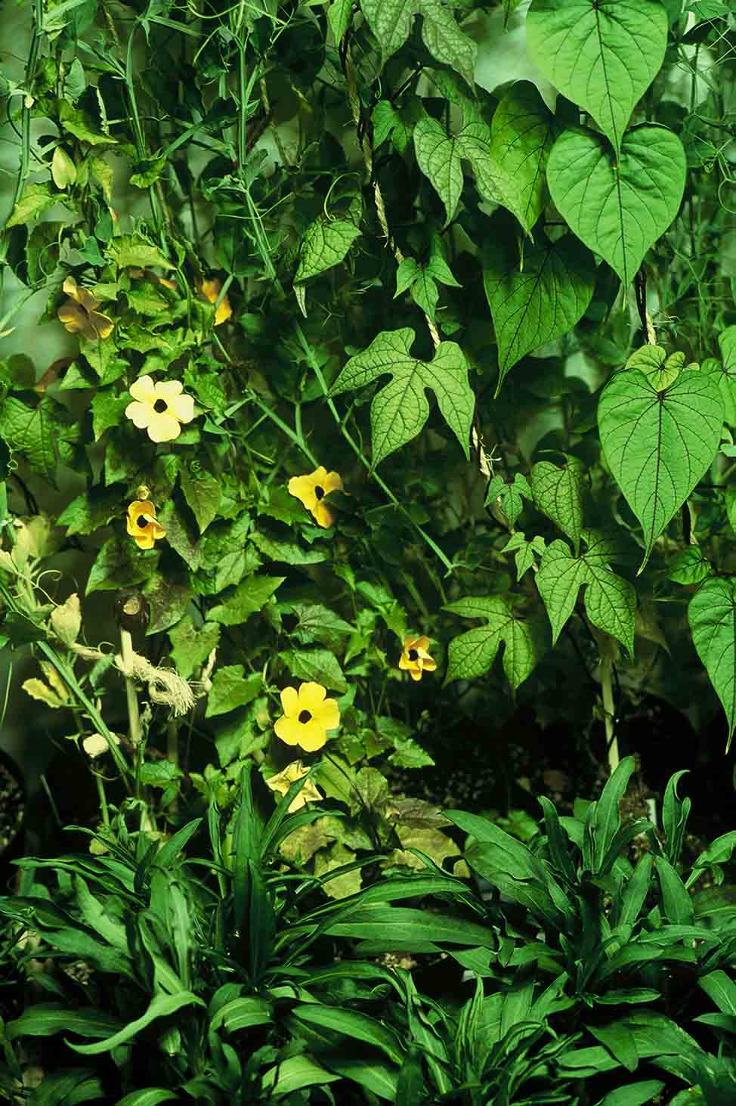
Figure 7 - Vines
Figure 8 - Soil

Models/Architecture
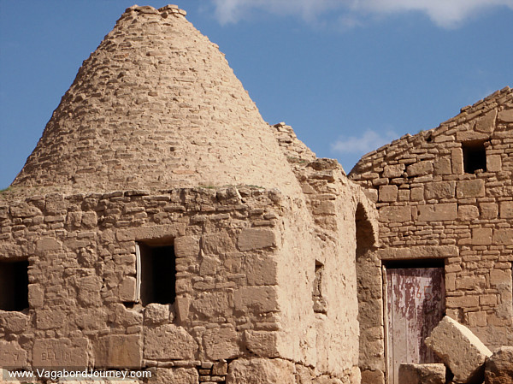
Figure 9 - Stone walls
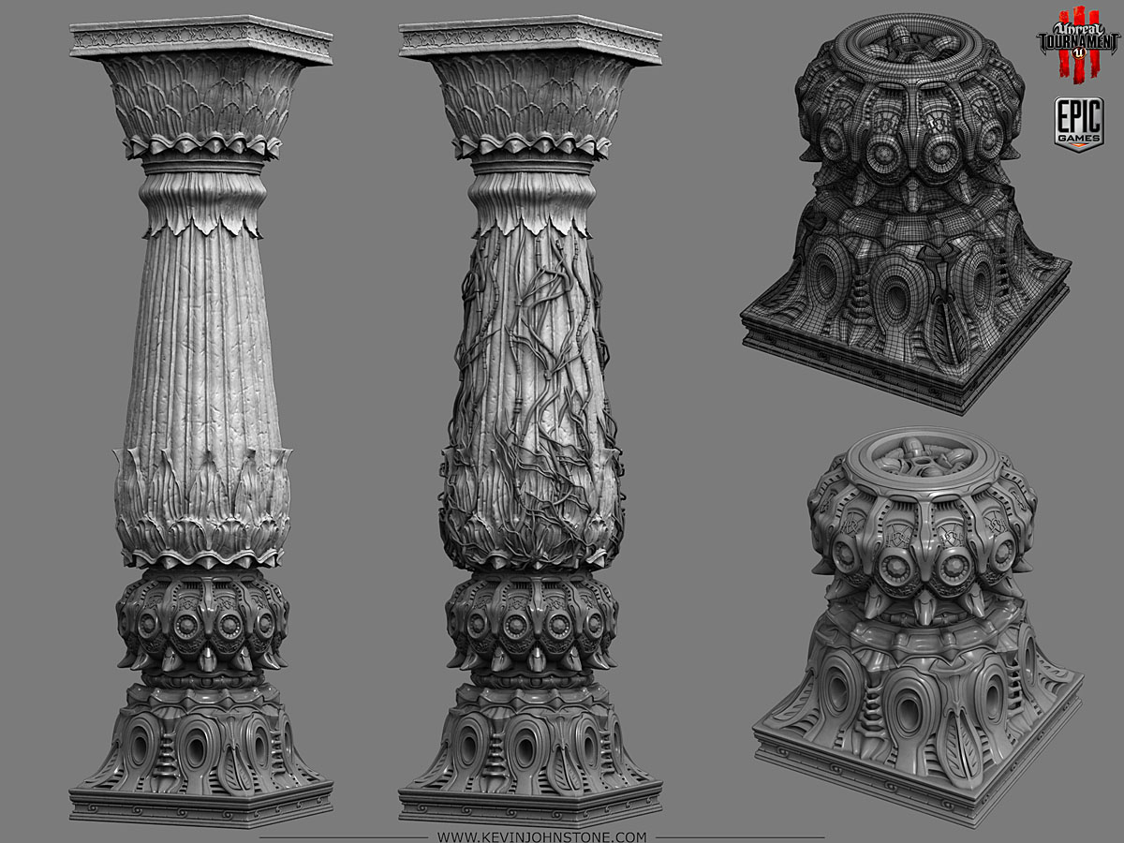
Figure 10 - NEC Columns
Figure 11 - Turkish Door
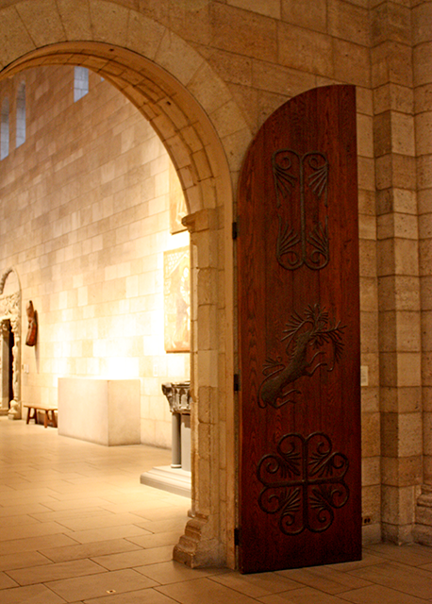
Figure 12 - Door Opened
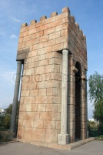
Figure 13 - Square Tower
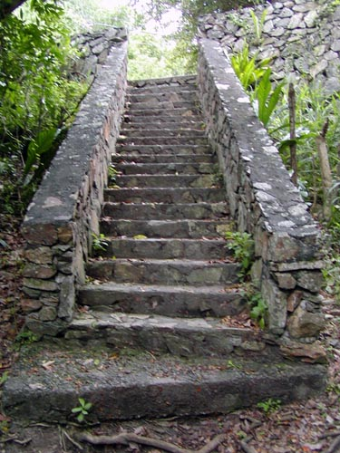
Figure 14 - Stone Steps

Textures/Lighting
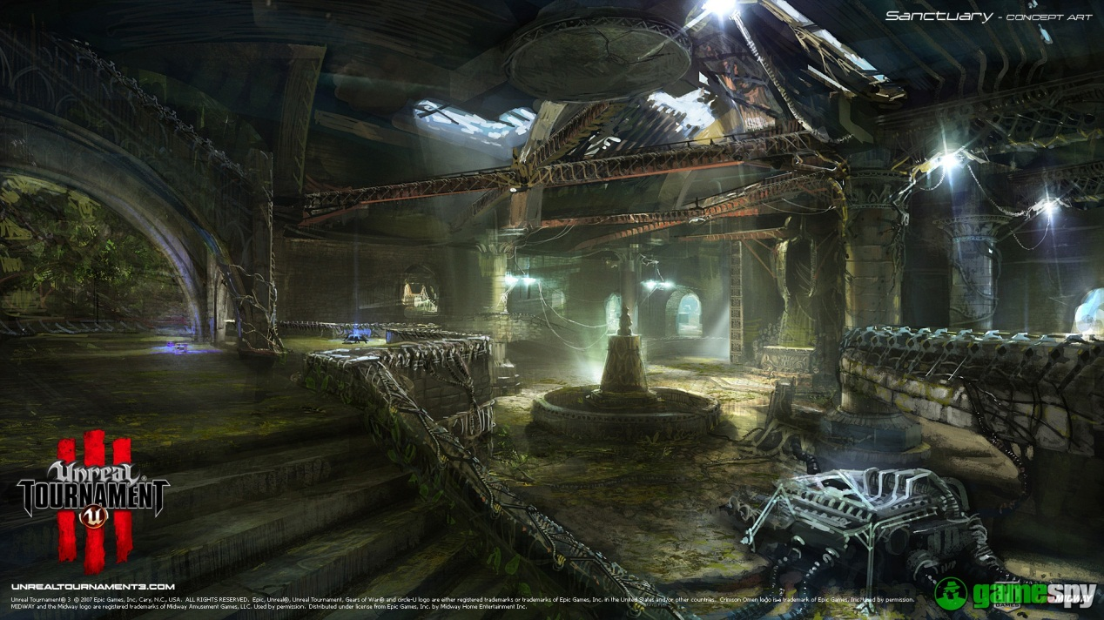
Figure 15 - Lighting Sample 1
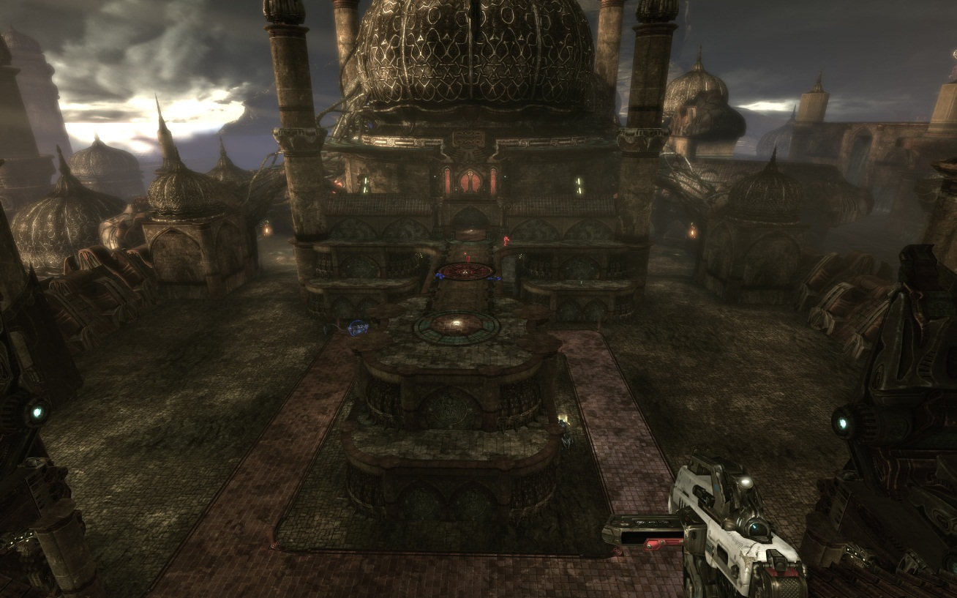
Figure 16 - Lighting sample with dust
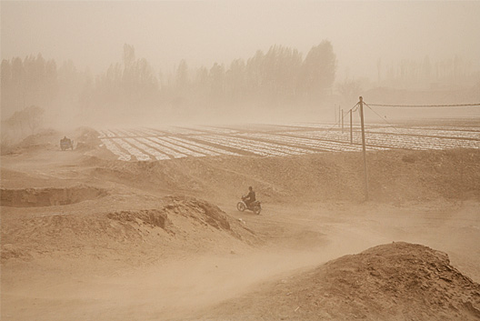
Figure 17 - Dust
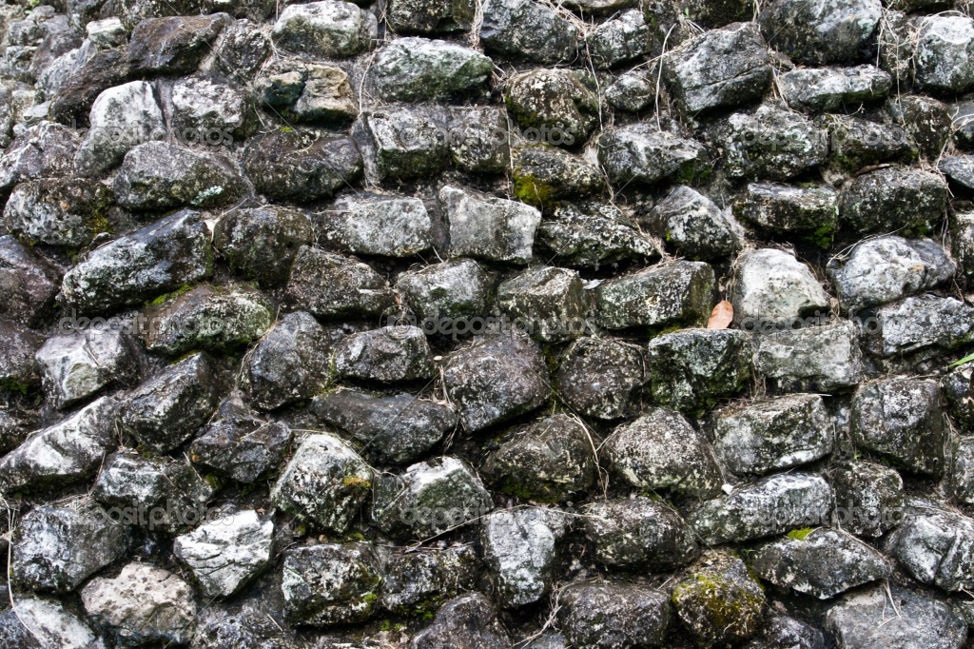
Figure 18 - Cobblestone Texture

Characters/Vehicles
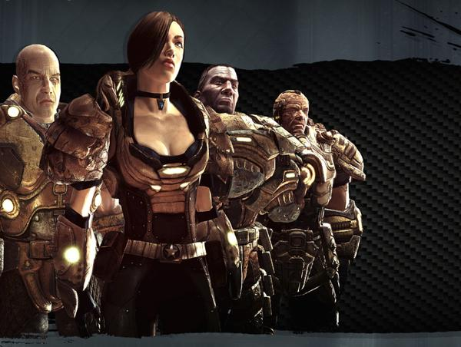
Figure 19 - Iron Guard characters
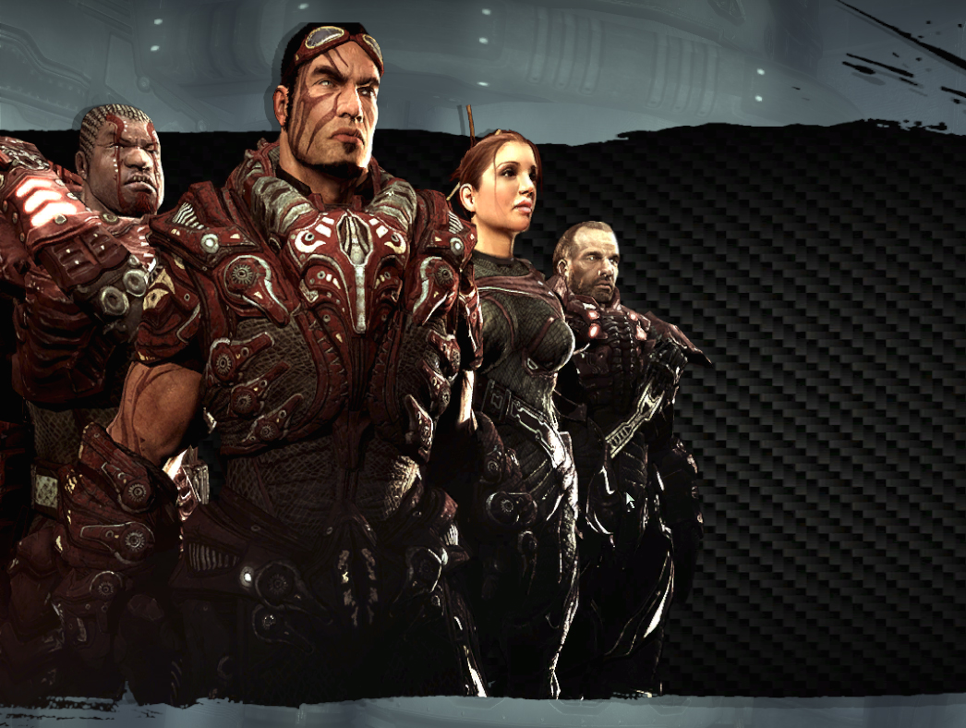
Figure 20 - Ronin characters
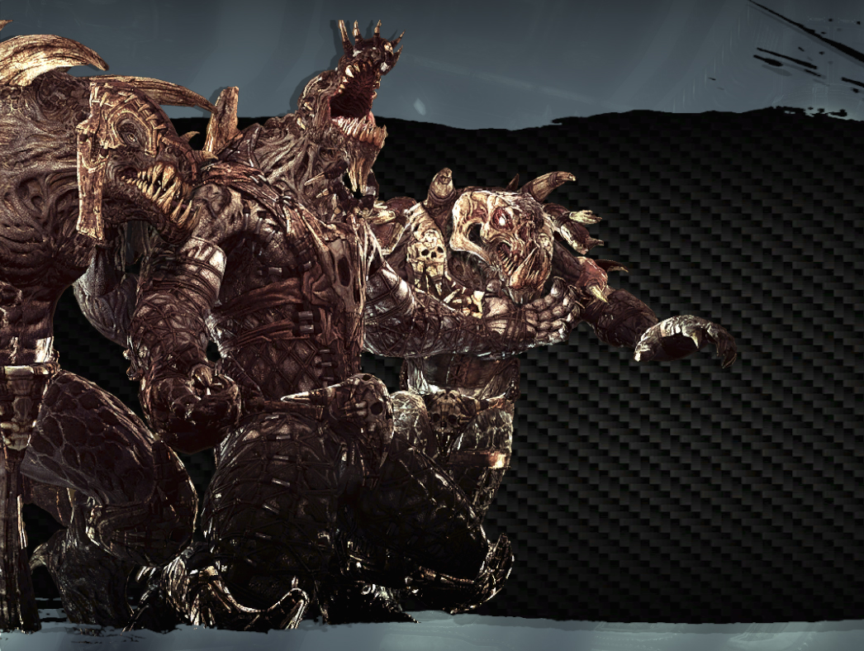
Figure 21 - Krall characters

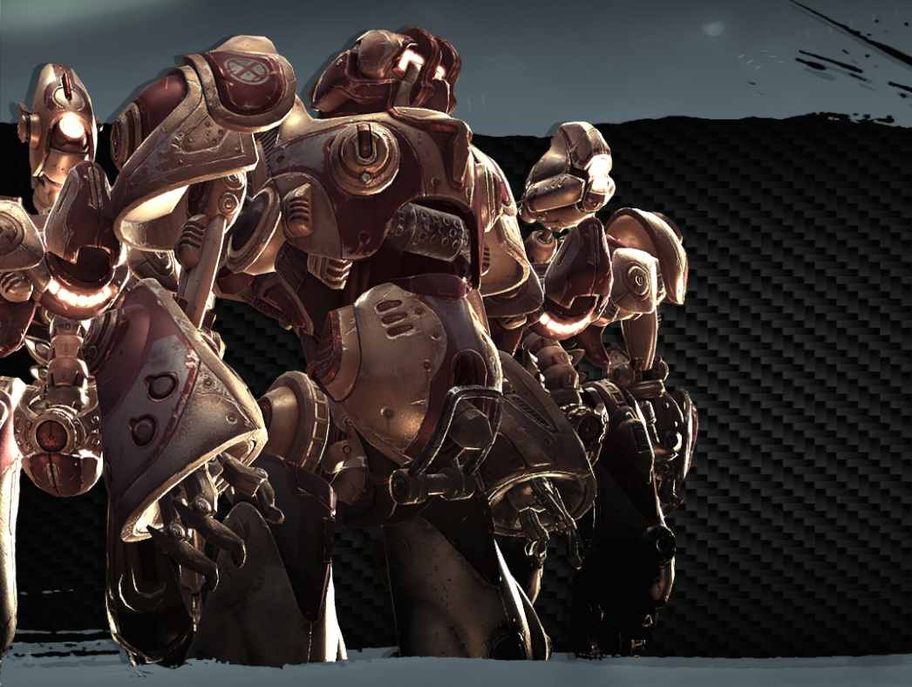
Figure 22 - Liandri characters

Area 2: The Stretch (and all of Second Floor)

The two towers and the second floor make up the area known as the Stretch. Warriors of old stretched their bodies diligently every day before attempting the jumps between towers. The towers line up to the second floor and have an opening for jumpers. The roof of the tower looks like a mosque and defines the Ottoman Empire's way of architecture. The other part of the second floor is made of the same stone blocks from the first floor, but with less dust and more light. Columns also stretch to the floor above it. A stone bridge connects across the stone blocked floor, giving access to the main tower that sits in the back of this area (much like the first and second floors). The tower on the second floor does not have a locked room. Instead, it is open and allows players to go in the back of the level to teleport down to the first floor room, or jump up to the third floor.

Visual References

Terrain/Vegetation
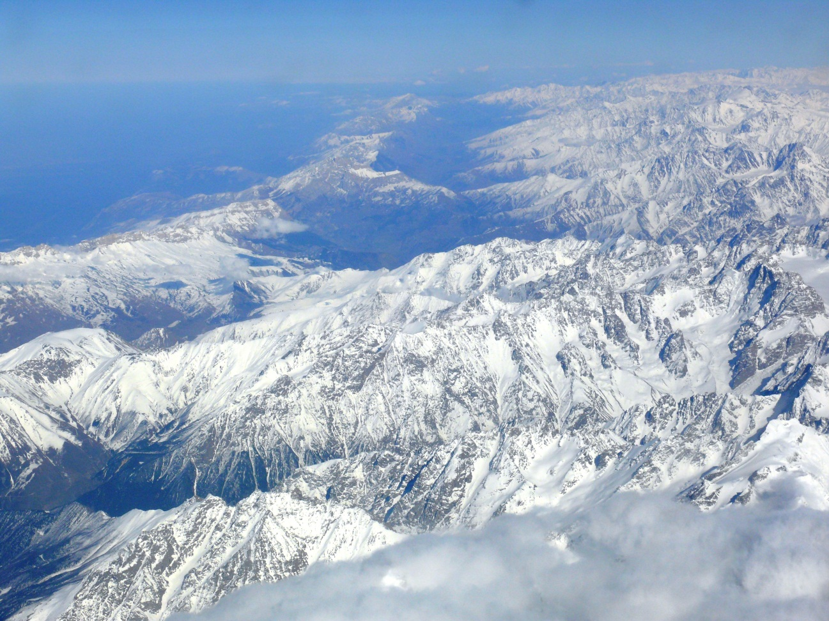
Figure 23 - Caucasus Mountains
Figure 24 - Cliffs above water
Figure 25 - More Cliffs near water
Figure 26 - Olive Tree

Figure 27 - Soil
Figure 28 - Vines

Models/Architecture
Figure 29 - Stone walls
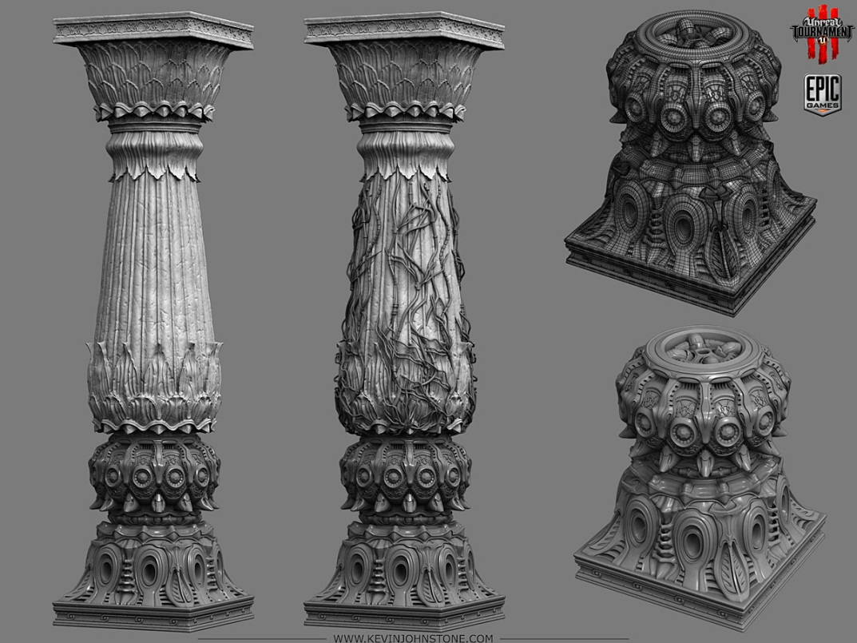
Figure 30 - NEC Columns
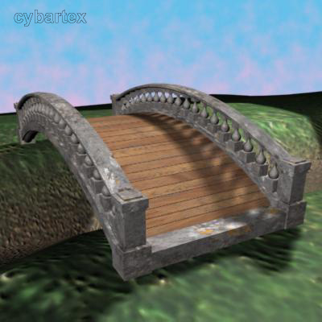
Figure 31 - Bridge 1
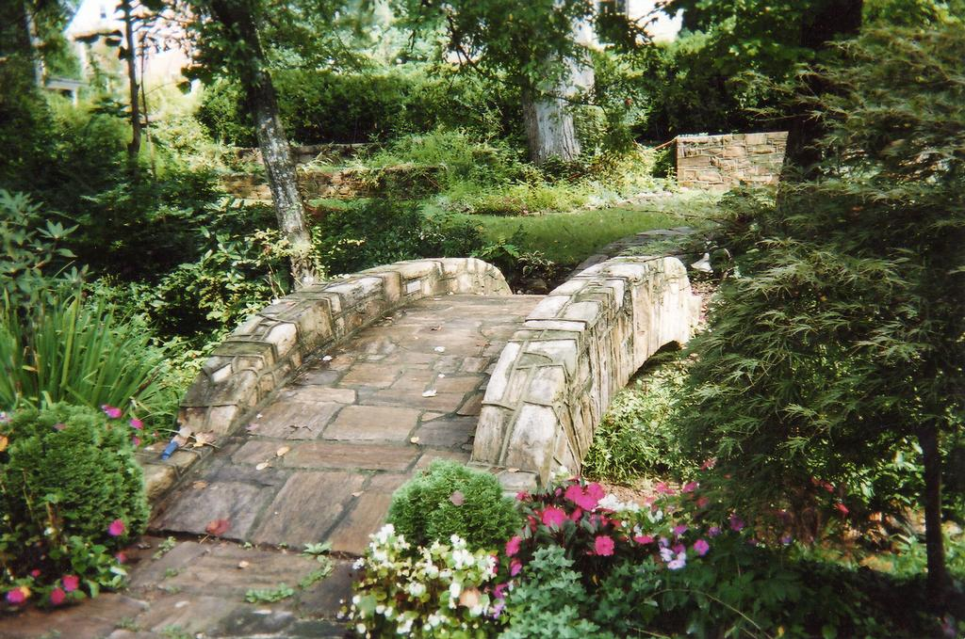
Figure 32 - Bridge 2
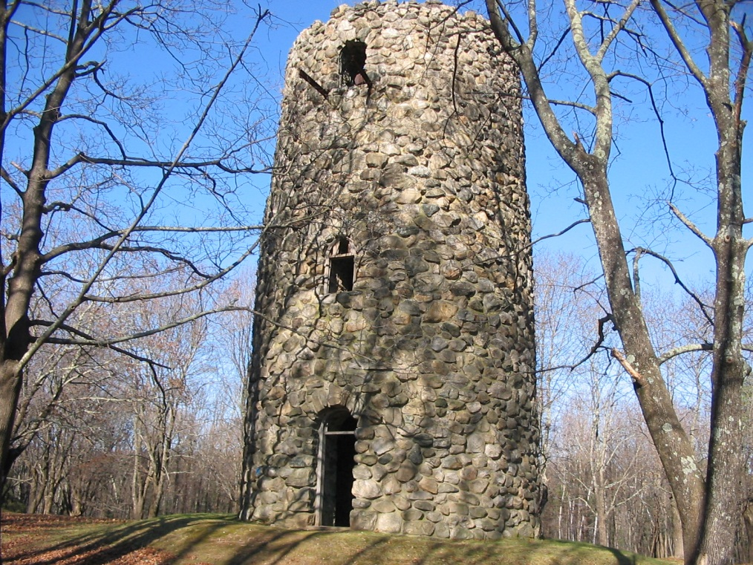
Figure 33 - Stone Tower
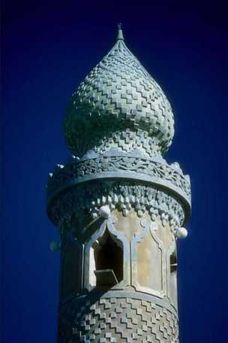
Figure 34 - Mosque Roof
Figure 35- Square Tower

Textures/Lighting
Figure 36 - Lighting Sample 1
Figure 37 - Lighting Sample 2
Figure 38 - Dust
Figure 39 Cobblestone texture

Characters/Vehicles
Figure 40 Iron Guard
Figure 41 Ronin
Figure 42 Krall
Figure 43 Liandri

Area 3: Climax (The Third Floor)

The third floor (not including the Sniper Roost) dubbed, Climax, was the final training ground for Turkish Warriors. On this floor, they jumped across platforms going through a tower. This required focus because the jump meant maintaining a horizontal jump while avoiding the roof of the tower. The tower's top looks like a giant mosque and contains vines. The stone blocks used everywhere else make up the floor of the platforms. The mountains now show much clearer and the area surrounding the level becomes much more real.

Visual References

Terrain/Vegetation
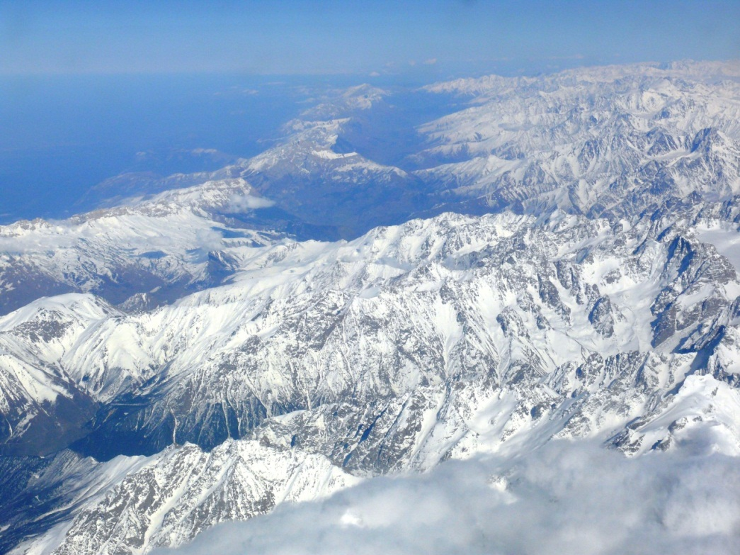
Figure 44 - Caucasus Mountains
Figure 45 - Cliffs near Water
Figure 46 - More Cliffs Near water
Figure 47 - Vines

Models/Architecture
Figure 48 - Stone Walls
Figure 49 - NEC Columns

Figure 50 - Mosque Roof
Figure 51 - Square Tower

Textures/Lighting
Figure 52 - Lighting Sample
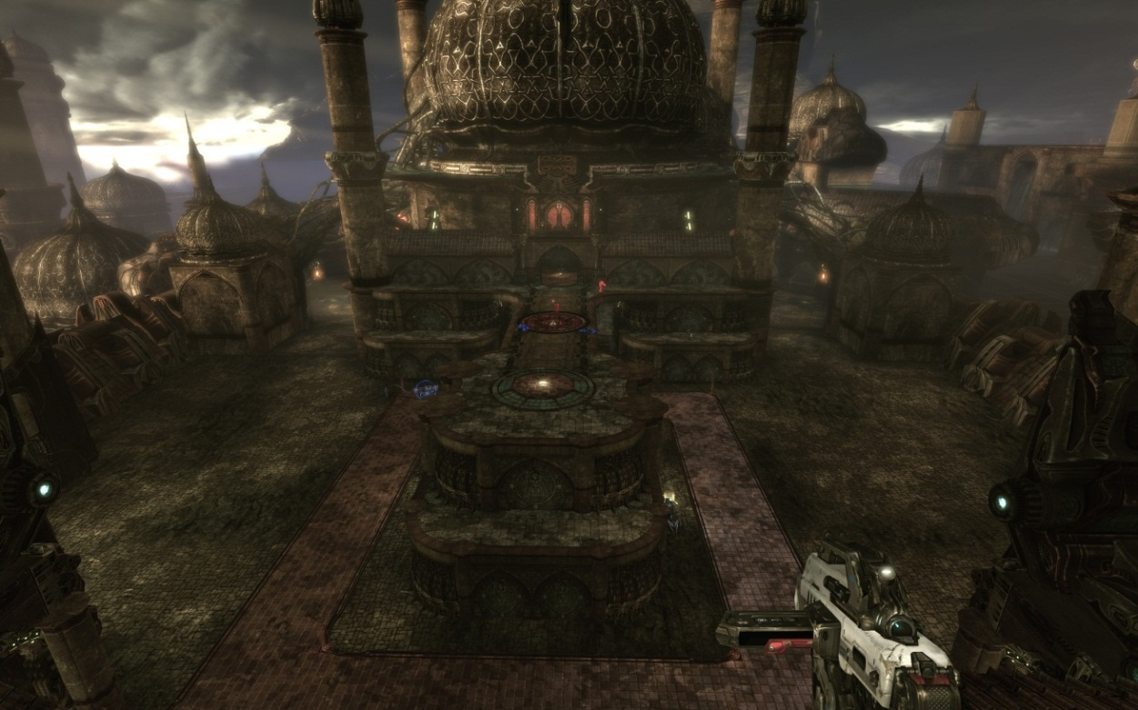
Figure 53 - Lighting sample 2
Figure 54 - Cobblestone texture

Characters/Vehicles
Figure 55 - Iron Guard
Figure 56 - Ronin

Figure 57 - Krall
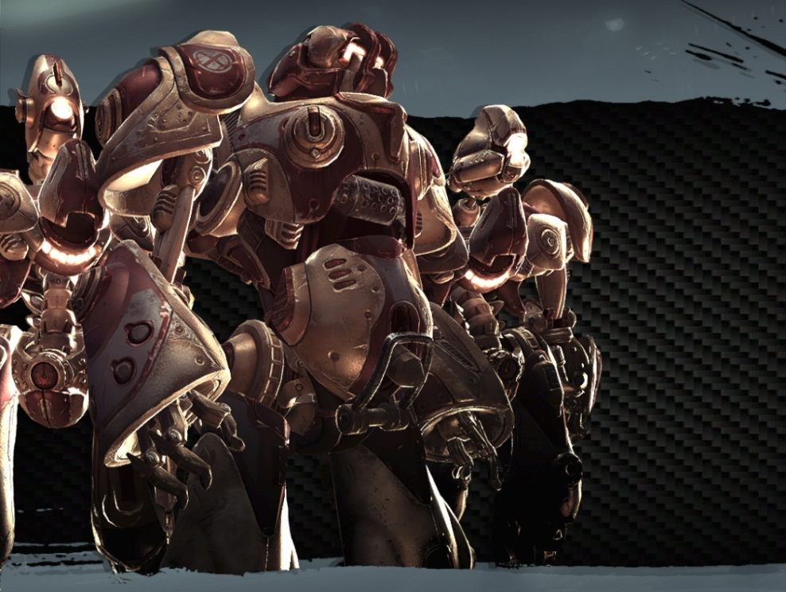
Figure 58 - Liandri

Area 4: Sniper Roost (The Third Floor Island)

The Sniper Roost sits out alone because it was once the meditation zone for aged masters. Since warriors rarely made the jump to this area, its preservation remained cleaner than most areas. This means less dust encompasses this area. The mountains closely hug this perch and support the backside of any snipers using it. Stairs run up and down the lower area of this perch and allow jumping from the first floor with the use of jump pads. Vines also line up and down the corners of the stone. Columns sit atop this perch but do not connect to anything since the construction never completed.

Visual References

Terrain/Vegetation
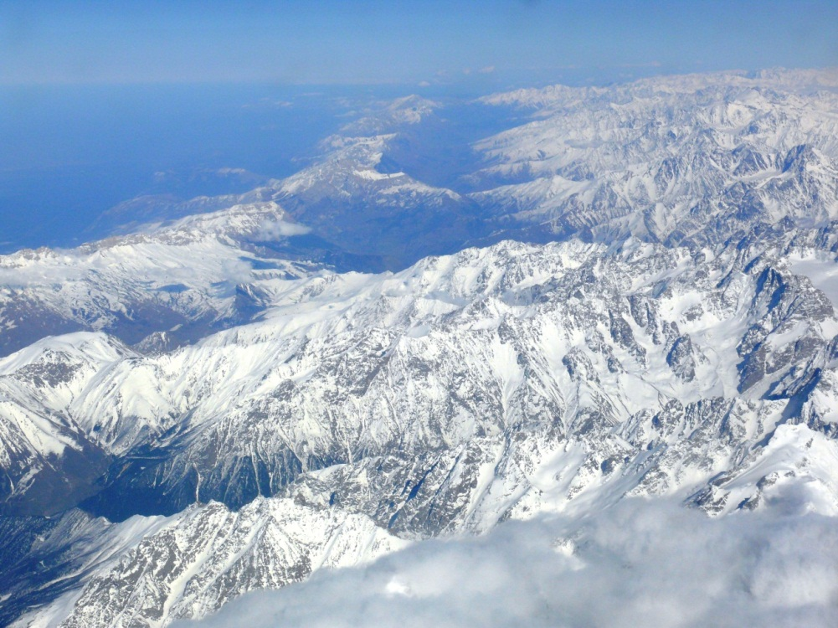
Figure 59 - Caucasus Mountains
Figure 60 - Cliffs near water
Figure 61 - More Cliffs Near water
Figure 62 - Vines

Models/Architecture
Figure 63 - Stone Walls
Figure 64 - Stone steps
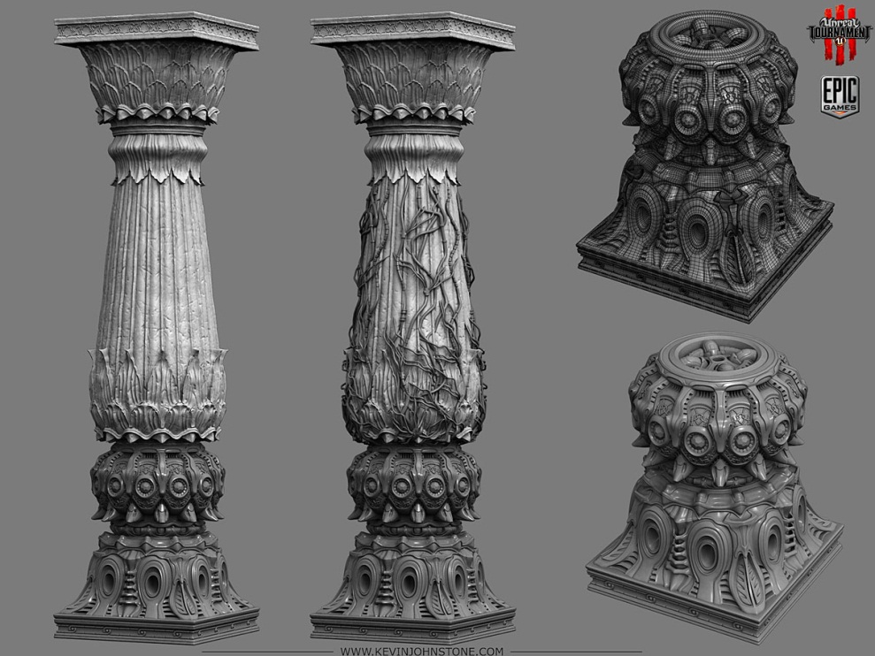
Figure 65 - NEC Columns

Textures/Lighting
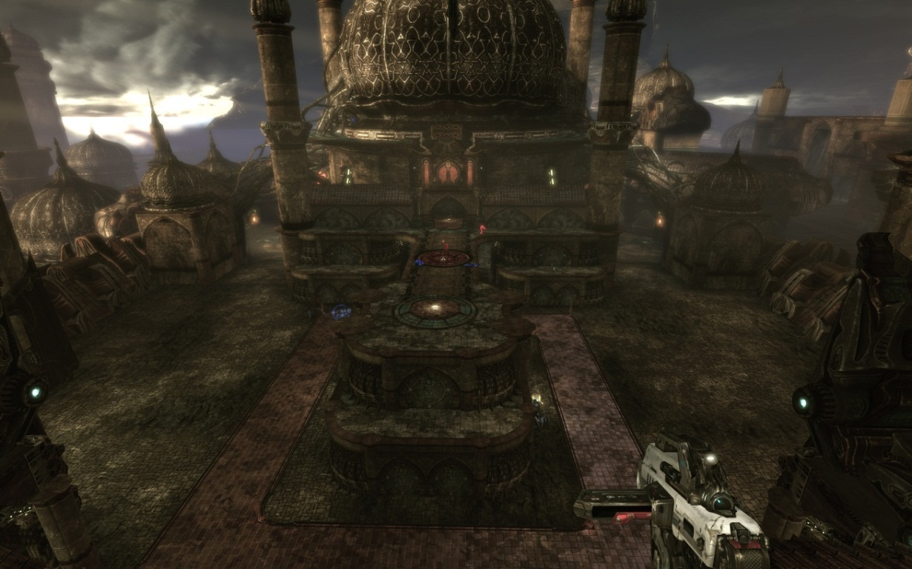
Figure 66 - Lighting Sample
Figure 67 - Cobblestone texture

Figure 68 - Dust

Characters/Vehicles
Figure 69 - Iron Guard

Figure 70 - Ronin
Figure 71 - Krall
Figure 72 - Liandri

Level Objectives
- Primary
  - Find a weapon
  - Kill Opposing Players until score reaches 20
  - Prevent other players from reaching 20
  - Do not die
- Secondary
  - Find ammunition for weapon
  - Find UDamage Upgrade for weapon
  - Find better weapons
  - Find pickups such as armor or health
- Bonus
  - None
- Hidden
  - Find Keg O' Health inside Base Tower Room

Challenge Highlights
Area #1: The Vulnerable Zone
- Combat
  - Pick up Link Gun and destroy opponents with it
  - Avoid shots from Sniper Roost or from platforms above
  - UDamage Pickup area creates a major choke point and combat area
  - Areas underneath second floor serve as a hiding spot from vertical predators
- Stealth
  - Utilizing columns or dust to sneak up on opponents
- Puzzles
  - Use jump pads to gain access to upper areas
- Conversation
  - N/A
- Boss Battles
  - N/A
Area #2: The Stretch
- Combat
  - Pick up Flak Cannon and destroy opponents with it
  - Avoid shots from Sniper Roost or from platform above
  - Shoot down to players on first floor
  - Shoot players as they use jump pads (Quad pad especially)
  - Escape combat with jump pads or jump directly down to first floor
- Stealth
  - No sneaking in this area or columns to exploit
- Puzzles
  - Use jump pads to gain access to upper area
  - Use teleporter to gain access to Keg O' Health in lower tower room
- Conversation
  - N/A
- Boss Battles
  - N/A
Area #3: Climax
- Combat
  - Pick up Rocket Launcher and destroy opponents with it
  - Avoid shots from Sniper Roost
  - Shoot down to players on first and second floor
  - Shoot players as they use jump pads (in the back of the level especially)
  - Escape combat with jump pads or jump directly down to second or first floor
- Stealth
  - No sneaking in this area or columns to exploit
- Puzzles
  - Use jump pad to get Vest armor and health pickups
- Conversation
  - N/A
- Boss Battles
  - N/A
Area #4: Sniper Roost
- Combat
  - Pick up Sniper Rifle and destroy opponents with it
  - Avoid players teleporting into this area to avenge themselves
  - Escape combat, take UDamage from first floor, and return for Super Sniping.
  - Grab thigh pads from lower part of Sniper Roost
- Stealth
  - No sneaking or columns to expose on this platform
- Puzzles
  - None
- Conversation
  - N/A
- Boss Battles
  - N/A

Water Cooler Moments
- Area 1: The Vulnerable Zone– The player discovers the hidden room on the first floor. The player utilizes the marginal jump pads to navigate the level.
- Area 2: The Stretch-- The player uses the teleporter in the back of the level to discover the Keg O' Health in the hidden room. Alternatively, the player uses the jump pads to jump from tower to tower.
- Area 3: Climax-- The player uses the jump pad to jump through a tower, grabbing armor and health on the way.
- Area 4: Sniper Roost--The player gains full perspective of the map and can rightfully pick off opponents.

Actors

Player
- Model(s):
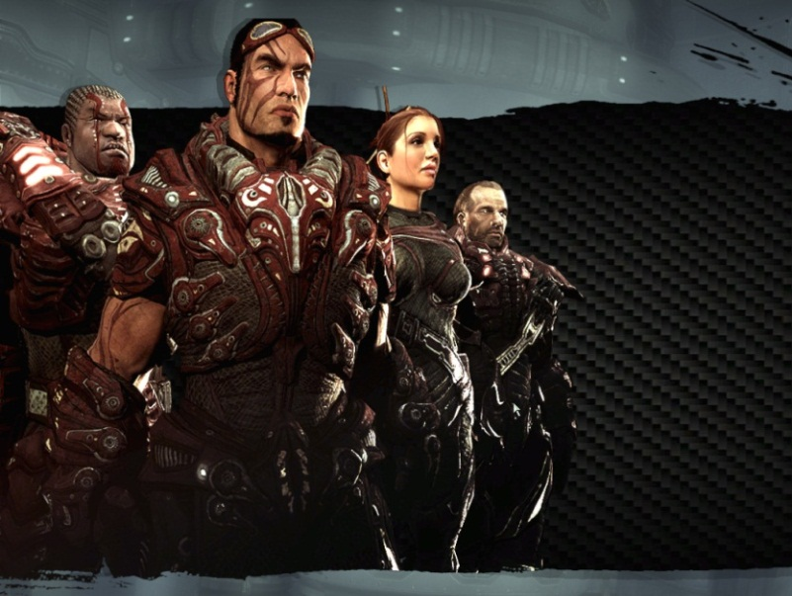
Figure 73 - Player chooses Ronin
- Inventory: Impact Hammer, Enforcer
- Start Location: Area 1, 2, or 3
- Motives/Objectives: Kill or die Trying

Key Actors

Actor 1: Krall Enemy
- Model(s):
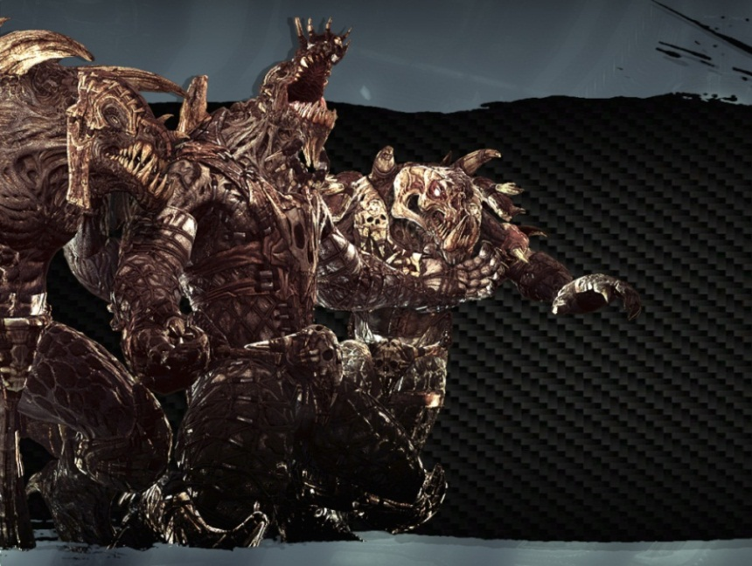
Figure 74 - Krall Enemy
- Inventory: Impact Hammer, Enforcer
- Start Location: Area 1, 2, or 3
- Motives/Objectives: Kill or die Trying

Actor 2: Iron Guard Enemy
- Model(s):
Figure 75 - Iron Guard Enemy
- Inventory: Impact Hammer, Enforcer
- Start Location: Area 1, 2, or 3
- Motives/Objectives: Kill or die Trying

Actor 3: Liandri Enemy
- Model(s):
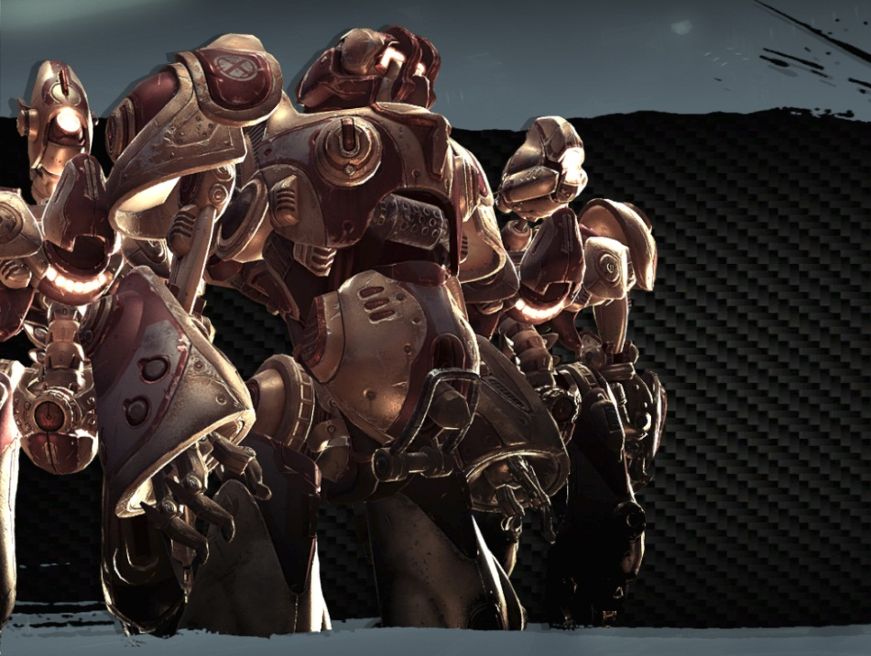
Figure 76 - Liandri Enemy
- Inventory: Impact Hammer, Enforcer
- Start Location: Area 1, 2, or 3
- Motives/Objectives: Kill or die Trying

Supporting Actors

N/A

User Interface
- Pre-Game Information
  - Briefing
    - Uses standard Unreal Tournament 3 Interface
- In-Game Information
  - Introduction
    - Uses standard Unreal Tournament 3 Interface
  - In-Game
    - Uses standard Unreal Tournament 3 Interface
  - Objectives
    - Uses standard Unreal Tournament 3 Interface
  - Conclusion/Debriefing
    - Uses standard Unreal Tournament 3 Interface
- Post-Game Information
  - Debriefing
    - Uses standard Unreal Tournament 3 Interface
  - Stats
    - Uses standard Unreal Tournament 3 Interface
- HUD Elements
  - Normal Elements Used

  - Special Elements Required

Gameplay Details

Gameplay Mechanics
- Prerequisite Skills
  - Running
  - Jumping
  - Primary weapon fire and secondary weapon fire
  - Collecting health and armor pickups
  - Using jump pads
  - Using teleporters
  - Knowledge of Deathmatch maps
- Skills Learned
  - Evasion
  - Strafing
  - A high degree of control over character maneuvering
  - Comfort with the usage of all weapon types
  - Spontaneous combat situation adaptability
  - Effective use of environmental objects such as jump pads
  - Effective use of armor and Powerups
  - Spatial coordination and map memorization

Level Overview Map and Key
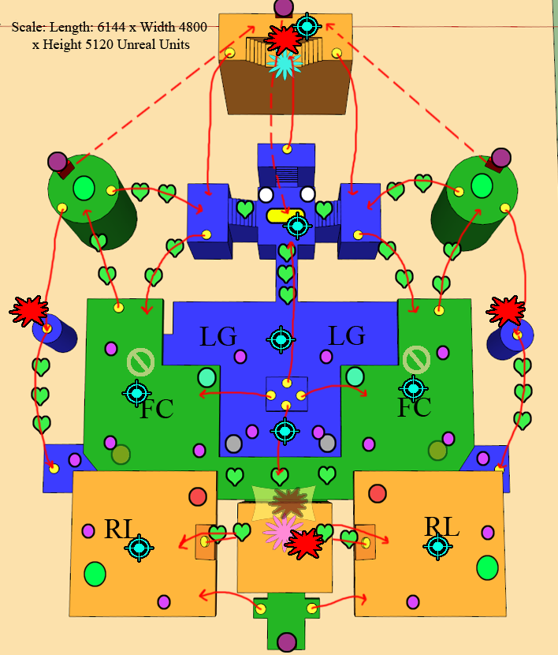
Figure 77 - Level Overview
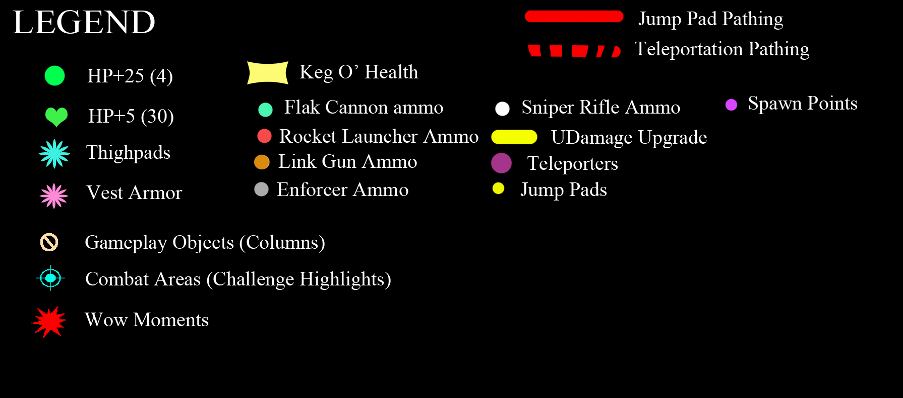
Figure 78 - Legend

Area Walkthroughs/Detailed Map Descriptions

Area 1: Vulnerable Zone
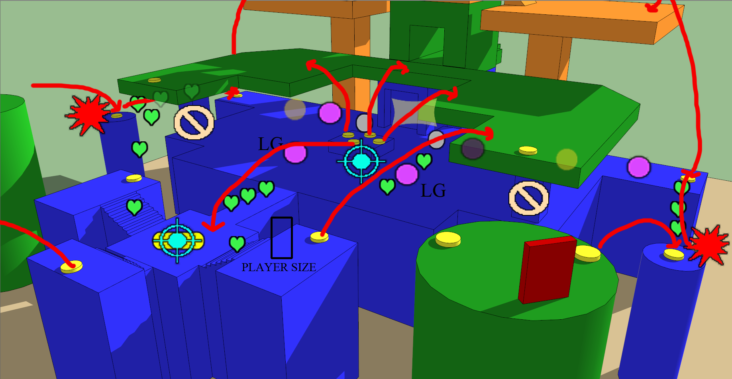
Figure 79 - Area 1: Vulnerable Zone
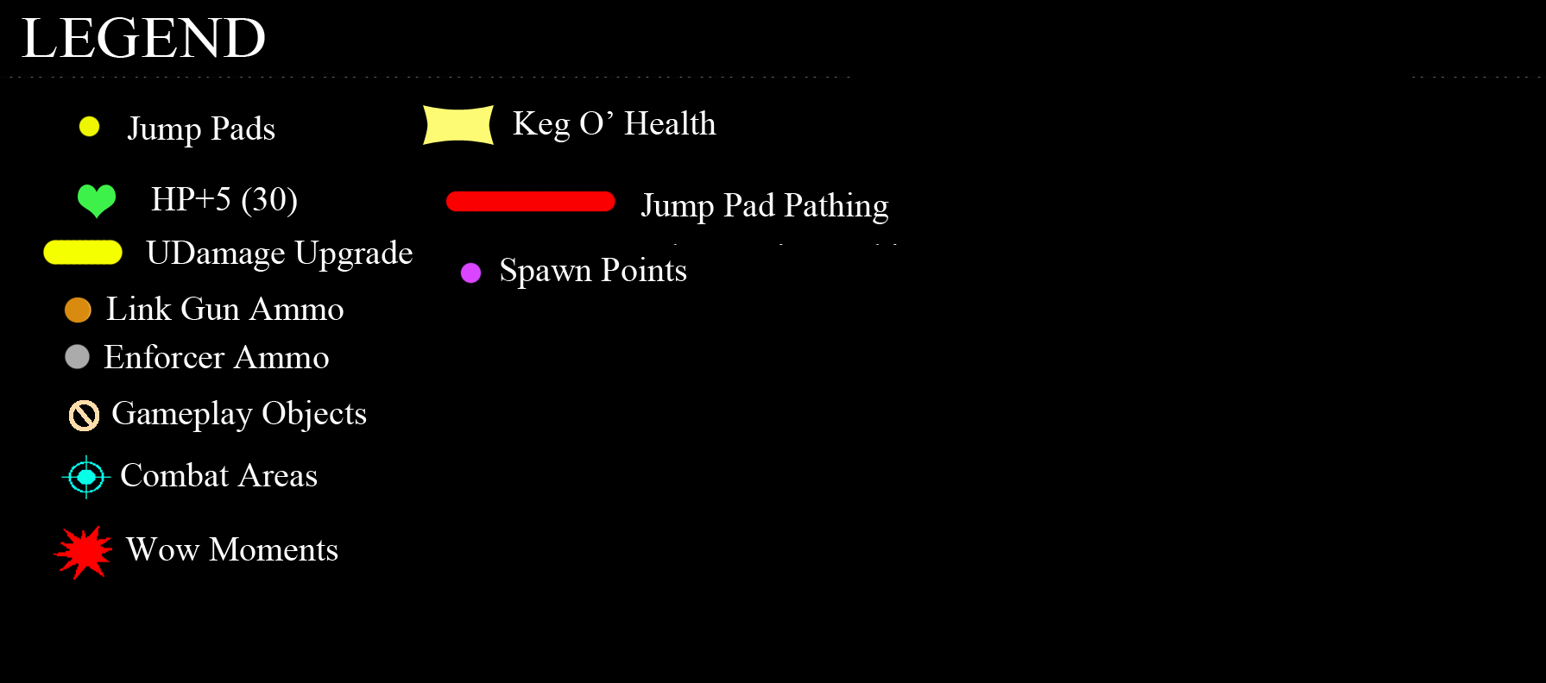
Figure 80 - Key to Area 1

Gameplay

The Vulnerable Zone gets its name from the position it sits in the level. Opponents can easily drop down to this area from the other areas or they can shoot down with the Flak Cannon or the Rocket Launcher. In order to escape the Vulnerable Zone, players use the Quad-pad (the four jump pads in the middle) and make it to the second floor, or they run to one of four other jump pads located close to the Sniper Roost, or the sides.

- Players confront each other for weapon pickups (Main path)
- Players head towards health pickups, or jump pads (Alternate Path)
- Support Structures (Gameplay Objects) provide initial cover at player spawns

Dialog
- "Play"
- "You are on Red/Blue Team" if Team Deathmatch

Visual References
Figure 81 - Door to Keg O' Health
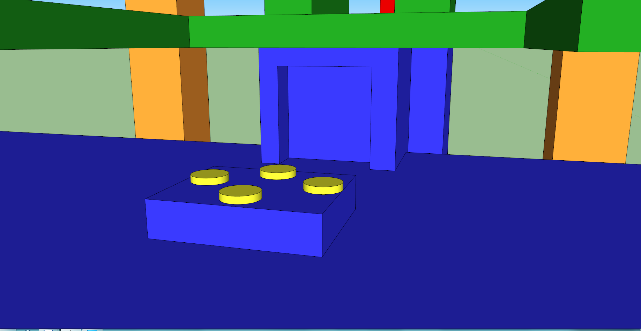
Figure 82 - Location of Door in Relation to Area 1

Area #2: The Stretch
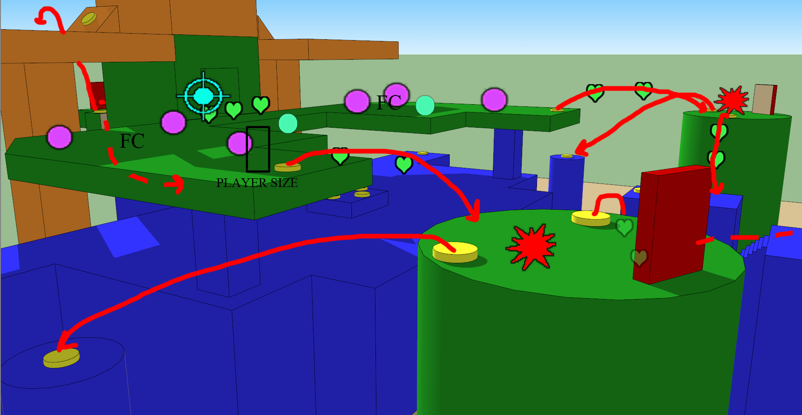
Figure 83 - Area 2: The Stretch

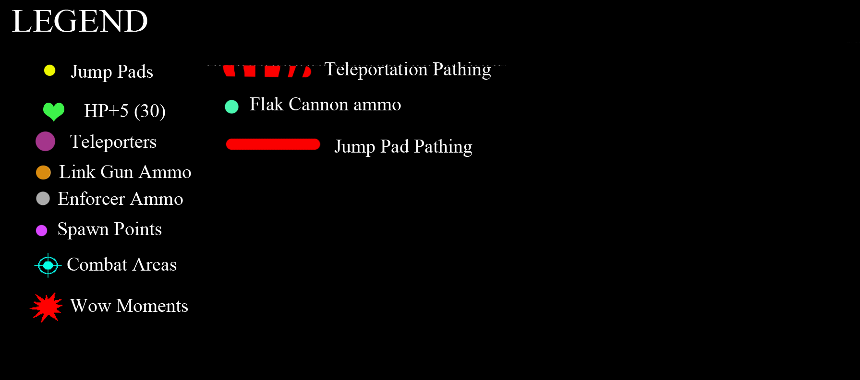
Figure 84 - Key for Area 2

Gameplay

The Stretch acts as the beginning and end for many players. Six of the sixteen spawn points originate in this area, and all of those spawns are near a Flak Cannon. The Flak Cannon's one-shot kill primary attack and explosive secondary attack make this zone extremely dangerous to enter or spawn.

- Players confront each other for weapon pickups (Main path)
- Players head towards health pickups, or jump pads (Alternate Path)
- Players use teleporters to go after Sniper Roost
- Players use back teleporter to get to Keg O' Health (Hidden Path)
- Players use back jump pads to get to third floor
- Players use jump pads or jump down to get to first floor

Dialog
- "Play"
- "You are on Red/Blue Team" if Team Deathmatch

Visual References
Figure 85 - Tower for Jumping
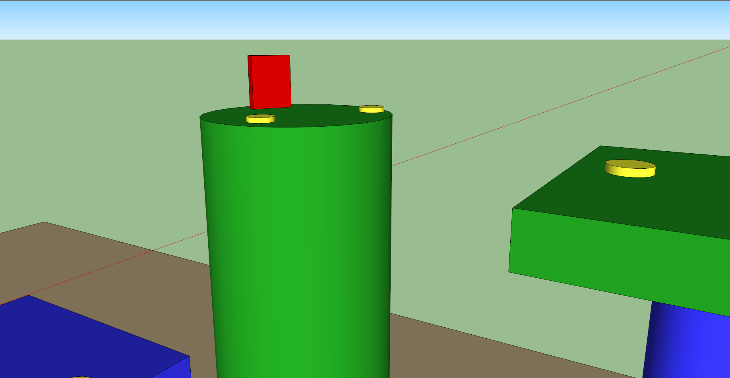
Figure 86 - Placement of Tower
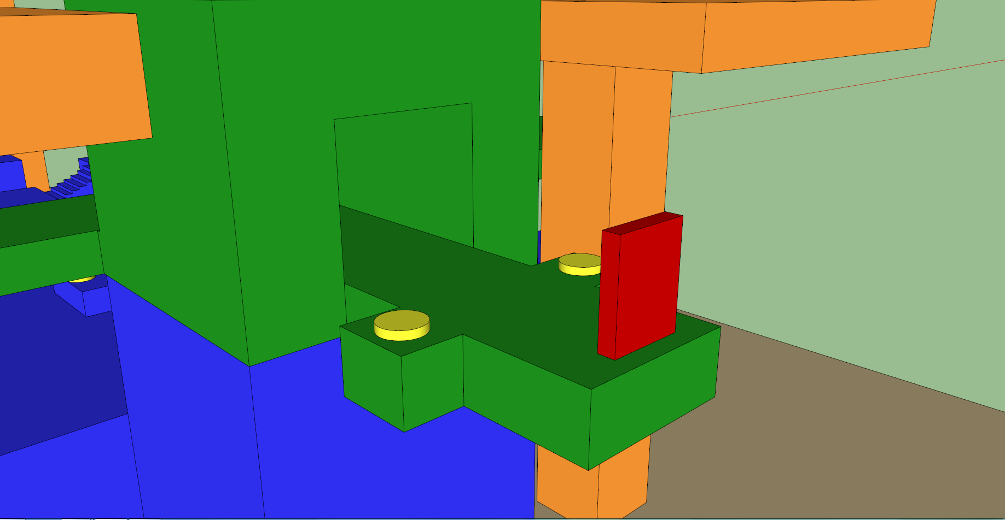
Figure 87 - Hidden Area

Area #3: Climax
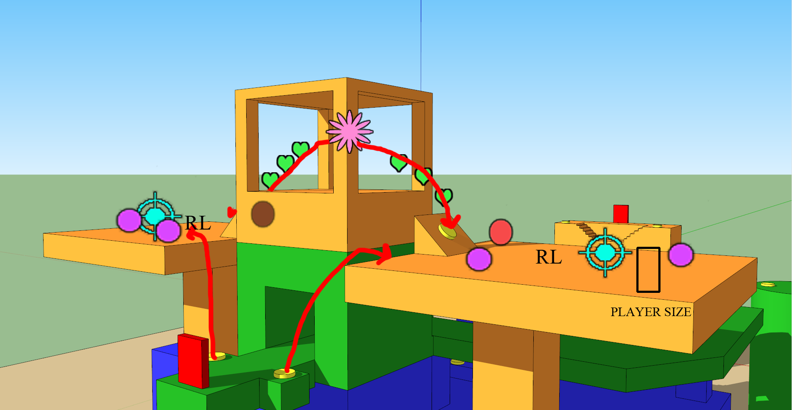
Figure 88 - Area 3: Climax
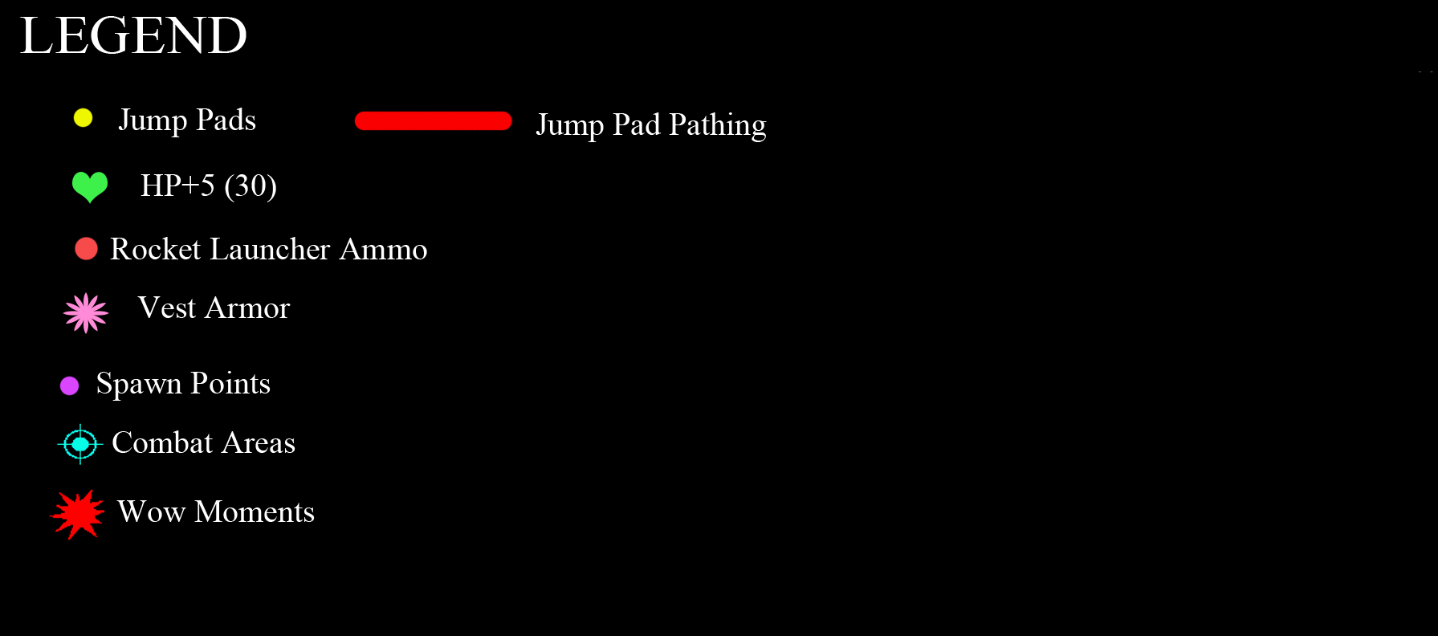
Figure 89 - Key for Area 3

Gameplay

Climax is the ultimate place to spawn because it offers the Rocket Launcher and Vest Armor. In addition, from the top, players drop down to the second or first floor to do anything they want. The area has no cover for the sniper roost and can also become a death zone.

- Players confront each other for weapon pickups (Main path)
- Players head towards health pickups, or jump pads (Alternate Path)
- Players jump down to get to second or first floor

Dialog
- "Play"
- "You are on Red/Blue Team" if Team Deathmatch

Visual References
Figure 90 - Mosque like Roof for Tower
Figure 91 - Placement of Mosque Roof

Area #4: Sniper Roost
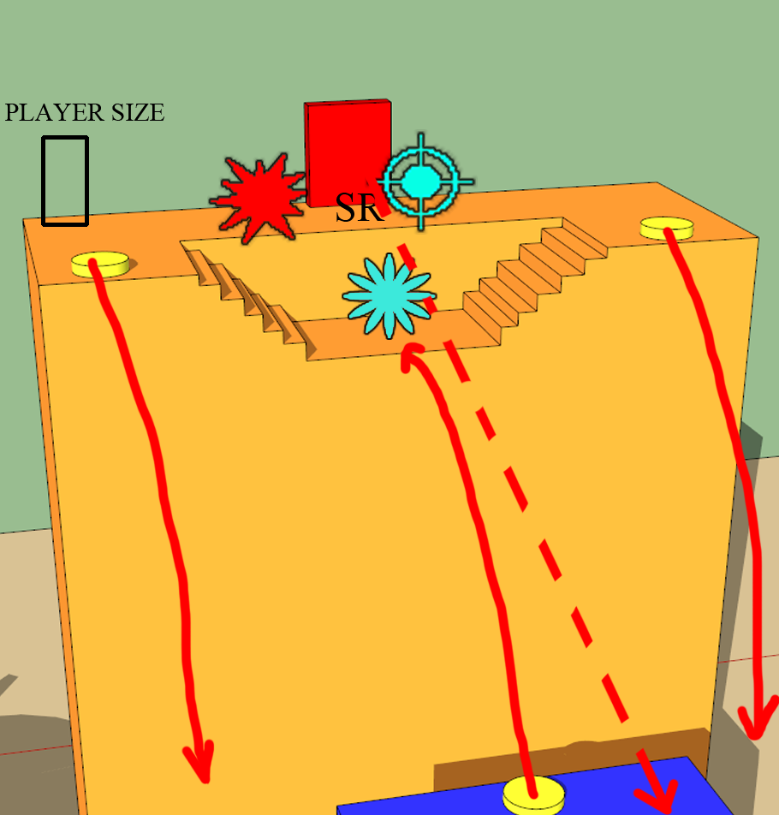
Figure 92 - Area 4: Sniper Roost
Figure 93 - Key for Area 4

Gameplay

The Sniper Roost delivers the perfect sniping spot. However, it only delivers this for a limited time. Since the area connects directly to all other areas, other players can easily attack snipers who use this roost. That means quick reflexes and a skilled sniper has a chance, while a person who normally camps does poorly. The Sniper ammunition is near the UDamage back in Area 1, which forces the Sniper to move out of the Roost to regain ammunition. In addition, the two towers from area 2 teleport straight to it.

- Players confront each other for sniper pickup(Main path)
- Players head towards Thigh pads (Alternate Path)
- Players jump down to retrieve ammunition (Alternative Path)
- Players snipe anyone across entire map
- Players switch to other weapons for close combat when needed

Dialog
- "Play"
- "You are on Red/Blue Team" if Team Deathmatch

Visual References
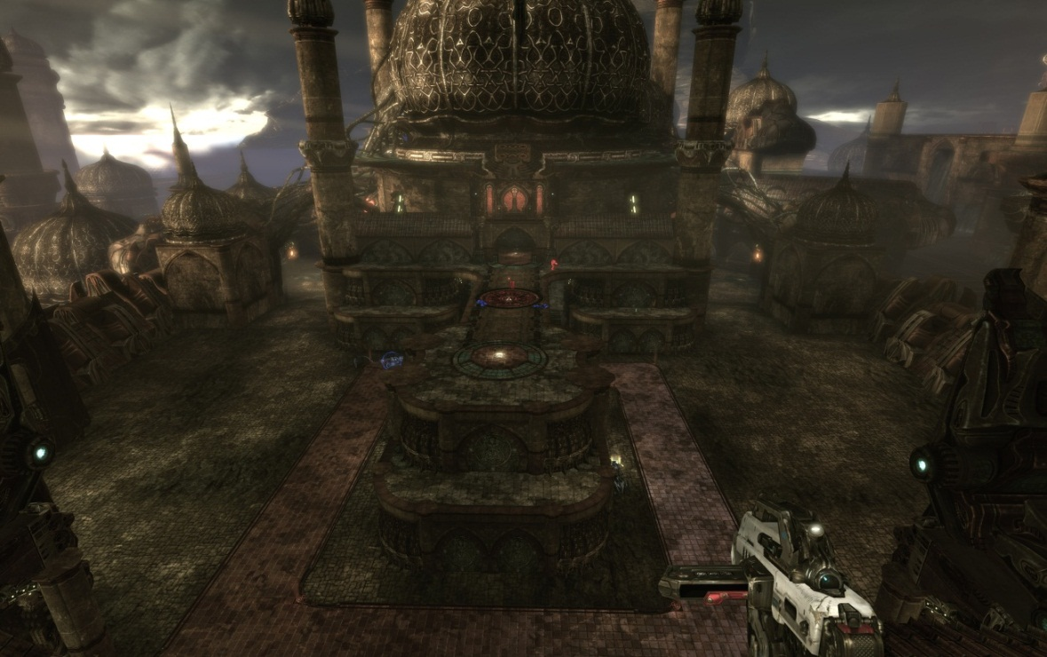
Figure 94 - View of Map (How it feels)
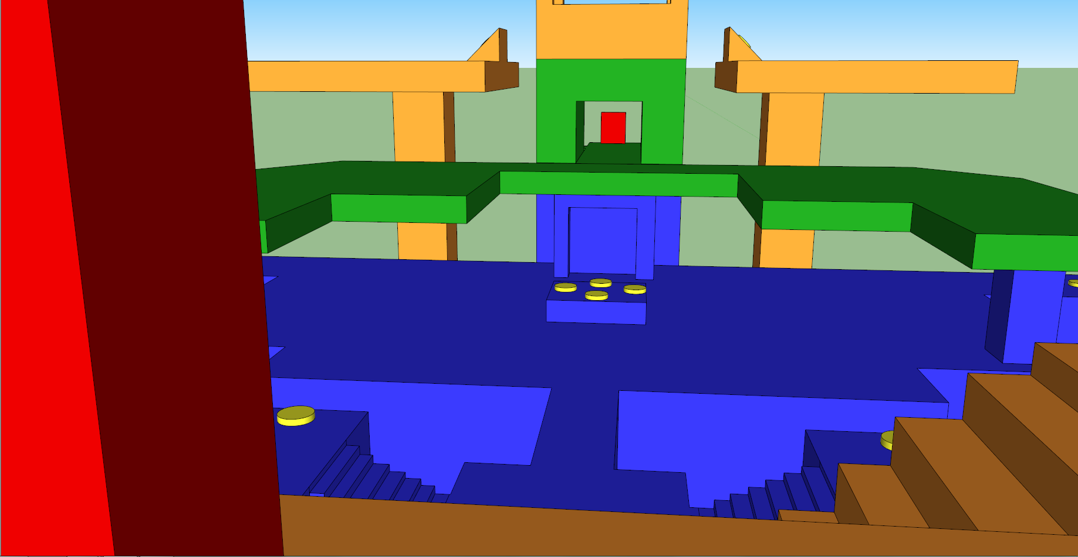
Figure 95 - View from Sniper Roost

References
Stone Structures:
http://www.vagabondjourney.com/2009-1/09-3390-architecture-beehive-houses.JPG
Dirt:
http://cdn.visiontoamerica.org/wp-content/uploads/2011/10/dirt.jpg?0673a6
Caucasus Mountain:
http://upload.wikimedia.org/wikipedia/commons/0/0d/Kavkasioni.JPG
Olive Tree:
http://www.tree-pictures.com/olive-tree2.jpg
Vines:
http://www.panix.com/~wbrodie/vines/Vines.jpg
Sanctuary Level Example:
http://ps3media.ign.com/ps3/image/article/818/818418/unreal-tournament-iii-20070906034512537.jpg
Lighting Sample:
http://syllogizing.com/images/ut3/ut3-high.jpg
Lighting sample 2:
http://pnmedia.gamespy.com/screenshots/unreal/50087317.jpg
Mosque:
http://www.islamicity.com/Mosque/ihame/aw88a.gif
Stone wall texture:
http://static3.depositphotos.com/1000528/108/i/950/depositphotos_1084125-Ancient-stone-wall-texture.jpg
Stone Stairs:
http://www.stjohnbeachguide.com/trails/stairs.jpg
Eastern Europe Design Texture:
http://www.lunchtruckparts.com/images/Eastern%20Europe/567860_sirian_textures_1.jpg
Dust:
http://www.walrusmagazine.com/dustbowl/images/dust-bowl-01.jpg
Bridge 1:
http://www.exchange3d.com/images/uploads/aff973/Fantasy%20Bridge/Stone_Bridge_thumbnail1.jpg
Bridge 2:
http://media.merchantcircle.com/10471445/The%20Bridge_full.jpeg
Cliff Rocks:
http://images.travelpod.com/users/kasparzzzzzzz/life.1156096800.williams_lake_0705_122.jpg
Cliff Lake:
http://bdnpull.bangorpublishing.netdna-cdn.com/wp-content/uploads/2010/05/1273275922_00dc.jpg
NEC Column:
http://www.kevinjohnstone.com/Images/UT3/Necris/NEC_DecoPillar.jpg
Arched Door:
http://pixabay.com/en/arch-architecture-building-castle-2764/
Small Tower:
http://images.colourbox.com/thumb_COLOURBOX3357984.jpg
Stone Tower:
http://greatergrafton.files.wordpress.com/2008/11/img_2670.jpg
Mosque Tower:
http://www.use.com/images/s_2/mosque_tower_22e10d3ea1a84f2bad87_1.jpg
Skinny Tower:
http://thumbs.dreamstime.com/thumblarge_482/1267218315nA1j3J.jpg
Opened Door:
http://www.sheilazellerinteriors.com/wp-content/uploads/2011/02/Cloisters-Arched-Doors-1.png
Cobblestone:
http://www.claeng.com/portfolio/texture_cobblestone1.jpg
Liandri:
http://media.giantbomb.com/uploads/1/14434/1088814-liandri.jpg
Iron Guard:
http://media.giantbomb.com/uploads/1/14434/1088792-iron_guard_super.jpg
Ronin:
http://media.giantbomb.com/uploads/1/14434/1088811-ronin.jpg
Krall:
http://media.giantbomb.com/uploads/1/14434/1088812-krall.jpg

Asset List
Asset Name | Type | Use | Link
S_NEC_Arches_SM_CABrick_CURb | StaticMesh | Placed in level
S_NEC_Buildings_SM_Octagon1 | StaticMesh | Placed in level
S_NEC_Buildings_SM_TurkRoof | StaticMesh | Placed in level
S_NEC_Ceilings_SM_Turk182a | StaticMesh | Placed in level
S_NEC_Deco_SM_BoneBrazier | StaticMesh | Placed in level
S_NEC_Deco_SM_Cuchulainn_Pose3 | StaticMesh | Placed in level
S_NEC_Deco_SM_Statue_Angle01_Body | StaticMesh | Placed in level
S_NEC_Deco_SM_Statue_Angle01_Plinth | StaticMesh | Placed in level
S_NEC_Deco_SM_Statue_Angel01_WingCurved | StaticMesh | Placed in level
S_NEC_Supports_SM_BabelSpireA | StaticMesh | Placed in level
S_NEC_Supports_SM_BabelSpireA4 | StaticMesh | Placed in level
S_NEC_Supports_SM_BabelSpireB3 | StaticMesh | Placed in level
S_NEC_Floors_SM_Walkway_Steps1 | StaticMesh | Placed in level
S_NEC_Lights_SM_Freelight01 | StaticMesh | Placed in level
S_NEC_Lights_SM_TurkChandelier01 | StaticMesh | Placed in level
S_NEC_Lights_SM_TurkLamp01 | StaticMesh | Placed in level
S_NEC_Lights_SM_WallLight01 | StaticMesh | Placed in level
S_NEC_Lights_SM_Walllight02 | StaticMesh | Placed in level
S_NEC_Pillars_SM_DecoPillar1 | StaticMesh | Placed in level
S_NEC_Pillars_SM_CASup2 | StaticMesh | Placed in level
S_NEC_Pillars_SM_DecoPillar4 | StaticMesh | Placed in level
S_NEC_Trims_SM_CAWallTrim_CURb | StaticMesh | Placed in level
S_NEC_Trims_SM_Deco_CURb | StaticMesh | Placed in level
S_NEC_Trims_SM_Deco_STRb | StaticMesh | Placed in level
S_NEC_Trims_SM_Vertebral_T01c | StaticMesh | Placed in level
S_NEC_Trims_SM_Vertebral_T01 | StaticMesh | Placed in level
S_NEC_Walls_SM_Archwalls_02 | StaticMesh | Placed in level
S_NEC_Walls_SM_CAWall_CURa | StaticMesh | Placed in level
S_NEC_Walls_SM_CAWall_CURc | StaticMesh | Placed in level
S_NEC_Walls_SM_CAWall_STRd | StaticMesh | Placed in level

